InsightPilot: An Agentic Platform for Conversational Business Intelligence

Project Workbook

By
Akshay Sunil Navani
Atharva Nitin Kulkarni
Pranjal Shrivastava
Shantanu Zadbuke
November 12, 2026
Advisor: Professor Vijay Eranti

Project summary. InsightPilot is a conversational business intelligence platform for enterprise data analysts. An orchestrator turns a business question into an analysis plan, an ordered set of tasks over named data sources, and shows it to the analyst for approval before anything runs. Specialist agents then carry out the plan: data fetch and analytics, with a visualization agent added in CMPE 295B. Each handoff between agents is a hop, and every hop records its lineage: the sources used, the query issued, the transform applied and the row counts in and out. Each hop is checked by a separate, simpler query, not by asking the model whether it is confident, so the analyst can inspect the one hop they doubt instead of redoing the whole analysis. The unit of work is the investigation: one business question taken to a verified answer. The project repository is https://github.com/akshaynavani/CMPE295A_InsightPilot.
Team responsibilities. Each member leads one technical area across both semesters and wrote the workbook sections listed against their name.
- Team responsibilities and section ownership
Member | Primary technical ownership | Workbook sections owned
Atharva Kulkarni | Orchestration tier: semantic resolver, plan synthesiser, orchestrator and replanner, model client | Literature Search (planning and agents), Ch. 3 requirements, Ch. 8 prototyping environment and sample programs; Ch. 6 services and sequence design; Ch. 8 status
Akshay Navani | Integration tier: Postgres and CSV/Excel connectors, application store, packaging | Literature Search (text-to-SQL), Ch. 5 architecture, Ch. 8 programming environment and development tools; Ch. 6 database design; Ch. 7 deployment plan
Pranjal Shrivastava | Verification and evaluation: hop verifier, cross-source reconciler, evaluation harness | Literature Search (reliability and evaluation), Ch. 4 dependencies, Ch. 8 prototype implementation plan, Ch. 9 schedule; Ch. 6 verification design; Ch. 7 test plan and evaluation; UI mockups
Shantanu Zadbuke | Presentation and delivery: investigation workspace, plan review, lineage inspector and export, audit log | State-of-the-Art Summary, Ch. 2 justification, Ch. 6 and Ch. 7 planning; Ch. 6 answer presentation; Ch. 8 progress log
Workbook 2 update. This submission completes Chapters 6 (Project Design) and 7 (QA, Performance, Deployment Plan), updates Chapters 8 and 9, and reports implementation progress as of November 12, 2026. Changes to Chapters 8 and 9 relative to Workbook 1 are shown in bold.

Literature Search, State of the Art

Literature Search
The literature relevant to InsightPilot falls into four areas: natural-language-to-SQL generation over realistic schemas, multi-step planning by LLM agents, agent reliability across chained steps, and automated machine learning on tabular data.
Natural language to SQL. Accuracy is high on clean benchmarks and falls sharply on realistic ones. On Spider 2.0, top systems reach 96.70% execution accuracy on the Snow setting, 76.23% on Lite and 65.60% on the DBT setting [1]. The 31-point drop comes from adding semantic-layer indirection and real project structure. On BIRD, with 12,751 question–SQL pairs across 95 databases, the best single model scores 80.04% against 92.96% for humans [2]. Annotation errors in these benchmarks are common enough that gaps of a few points between leaderboard entries are not meaningful [3], so this project measures accuracy on its own fixed question set instead of citing leaderboard differences. The errors that remain are often silent. A study of 4,602 incorrect queries from in-context-learning text-to-SQL techniques found that schema errors, such as referencing a column that does not exist, cause 81.2% of the queries that fail to execute, so the database itself reports them. Semantic errors are different: 30.9% of all errors were queries that ran successfully but misread the question or the schema, returning a plausible but wrong result [4]. That silent failure mode shapes this project's design. Arctic-Text2SQL-R1 shows that training on execution feedback lets small models compete with much larger ones [5]. This project applies the same signal at inference time: database errors are returned to the generator in a query repair loop.
Multi-step planning and data reasoning. The orchestrator depends on multi-step analytical reasoning, the weakest capability measured in the literature. DABstep [6] contains 450 tasks drawn from a real financial-analytics workload, 84% of them classed as Hard. The best agent scores 14.55% on the Hard tasks against 76.39% on the Easy ones, and the authors describe multi-step tasks as largely unsolved. A survey of evaluation tools for data-science assistants and agents [7] finds that existing benchmarks focus on a small set of goal-oriented activities and largely ignore data management and exploratory analysis.
Agent reliability and error propagation. First, consistency is lower than average accuracy suggests. τ-bench [8] introduces pass^k, the probability that an agent solves the same task in all k trials. Its best function-calling agent succeeds on 61.2% of retail tasks in a single trial, but its pass^8 falls below 25%. An analyst who asks the same question twice and gets two different answers cannot rely on either. Second, errors compound across steps. If each step were independently 95% accurate, a ten-step chain would be correct about 60% of the time, and at 90% per step about 35%. Two failure studies show where this happens. A taxonomy of agent failures across memory, reflection, planning and action modules finds that a single root-cause error propagating through later steps is the main cause of task failure [9]. A diagnostic study of tool invocation finds tool-initialisation failure to be the leading error, at an 89% error rate for a 3-billion-parameter model and absent in large models [10]. That result bounds the deployment design: the orchestration layer must call a frontier-class model rather than a small local one.
Agent task horizon. METR measures the length of task, in human working time, that agents complete with 50% reliability. That horizon has doubled about every seven months over six years [11], and about every three months since 2024 [12]. This is the strongest evidence that a system like InsightPilot is now worth attempting. The horizon is measured at 50% reliability, though, so it shows a trend rather than readiness: an analytical answer that is right half the time has no value.
Automated machine learning on tabular data. MLE-bench evaluates agents on 75 Kaggle competitions, each scored by its original metric [13]. AutoMLGen reaches a 36.4% average medal rate, with 18.7% gold, under a 12-hour budget [14]. Conversational products have begun to expose this capability: Qlik's Predict agent trains regression and classification models from natural-language requests inside Qlik Answers [15]. A conversational workflow cannot contain a 12-hour step, however, so any modelling step in this project therefore has to be time-boxed in minutes and must report what it did not attempt.
Research gap. These areas are mostly studied in isolation, and the commercial systems in the next section secure correctness by requiring a human-authored semantic model before a question is asked. Recent systems cover parts of what this project needs. Data Interpreter [16] and AgenticData [17] plan and refine multi-step analyses over heterogeneous data. RADAR [18] records each operation's inputs and observations, rejects operations that conflict with them, and measures silent errors directly: across 1,054 tasks it reduces them from 405 to 289 against the strongest baseline. Databricks Genie Inspect checks a generated query by writing smaller verification queries, but within a single query rather than across a plan [20]. We found no system that verifies every hop of a multi-source plan with an independent query, structures its lineage so that checking an answer costs less than re-deriving it, and reports multi-hop execution accuracy alongside a silent-error rate. InsightPilot builds and measures such a system for enterprise data analysts.

State-of-the-Art Summary
Commercial conversational BI products share one correctness mechanism: they answer inside a scope that someone has curated in advance. Snowflake Cortex Analyst generates SQL against a semantic view, which can be written by hand or drafted with Semantic View Autopilot [19]. Databricks AI/BI Genie answers over a Genie Agent (formerly a Genie space) of up to 50 tables, views or metric views [20]. Power BI Copilot answers from one semantic model and can generate ad hoc DAX for calculations the model does not contain, but it cannot forecast or detect anomalies [21]. Tableau Pulse is built around pre-defined metrics: it pushes changes to users and, with Tableau+, answers questions only within those metrics [22]. Enterprise budgets follow this approach. In a survey of 818 organisations with more than $100M in revenue, nearly 59% are directing new budget to semantic layers, and 24.9% name accuracy and hallucination risk as their top concern about generative AI in analytics [23].
The approach is sound: a curated semantic layer prevents many of the semantic errors described in the Literature Search, where a query runs but misreads the schema [4]. Its limits are moving outward, through automated drafting, larger table limits and ad hoc calculations, but the scope is still prepared before the question is asked. A question that needs data nobody has added to the model cannot be answered until someone adds it.
First, verification is reaching products. Genie's Inspect, in Public Preview since March 2026, reviews the SQL Genie generated, runs smaller queries to verify specific parts of it, and generates improved SQL as needed [20]. Power BI Copilot with Fabric IQ shows its reasoning steps, the DAX query and the data behind each answer [21]. Both check or expose one answer within one curated scope; neither verifies each step of a plan that spans sources. Second, the Model Context Protocol, released by Anthropic in November 2024 [33] and contributed to the Linux Foundation's Agentic AI Foundation in December 2025 [34], standardises how agents access tools but not what the data means [24]. It makes a pluggable connector layer practical for a small team but leaves schema understanding unsolved.
The category also has a record of failure. IBM discontinued Watson Analytics in 2019 [25]. Narrative Science was acquired by Salesforce and folded into Tableau in 2021 [26]. Sisu Data raised about $128.7M for automated diagnosis and joined Snowflake in 2023 [27]. Power BI Q&A is being fully retired in December 2026 [28]. None of these failed for lack of distribution.

- Leading industry offerings compared with this project
Offering | Primary customer | What it provides | Gap for the enterprise analyst
Snowflake Cortex Analyst [19] | Snowflake enterprises | Text-to-SQL over a semantic view, written by hand or drafted with Semantic View Autopilot | Answers only over Snowflake data described in a semantic view
Databricks AI/BI Genie [20] | Lakehouse enterprises | Conversational SQL over a Genie Agent of up to 50 tables; Inspect verifies its own generated SQL | Scope fixed by the Genie Agent's tables; verification covers one query, not a multi-step plan
Power BI Copilot [21] | Fabric customers | Natural language over a Power BI semantic model, including ad hoc DAX; Fabric IQ shows reasoning steps and the DAX used | Answers only within one semantic model; no forecasting or anomaly detection
Tableau Pulse [22] | Tableau Cloud customers | Metric monitoring with natural-language summaries; Q&A on Tableau+ | Limited to insights from pre-defined Pulse metrics
Wren AI [29] | Open-source GenBI users | Open-source agent with its own modelling language (MDL); about 18,000 GitHub stars; dry-plan SQL validation | Requires an MDL model of the data; validation is per query
Hex Notebook Agent [30] | Analysts working in notebooks | Agent in a SQL and Python notebook that can draft a plan and run multi-step work, showing each change as a diff | A plan is optional guidance, not an enforced structure; the analyst reviews each change
This project | Enterprise data analysts | A plan approved before it runs, executed across Postgres and CSV/Excel files (REST APIs in CMPE 295B), with every hop checked by an independent query and recorded as lineage | Not applicable

Leading-edge techniques adopted: hybrid schema linking with reciprocal rank fusion and margin-based ambiguity detection; constrained generation into a typed plan DAG with static validation before execution; verification by decomposition in the style of Genie's Inspect [20] but applied across a multi-source plan; execution-feedback query repair [5]; consumption of an existing dbt semantic layer when present rather than requiring a new one; and repeated-trial reliability measurement using pass^k [8].
Published accuracy. None of the major BI platforms reviewed here publishes product-level execution accuracy on BIRD or Spider 2.0. Vendors publish scores for their models, such as Arctic-Text2SQL-R1 [5], and specialist data-agent companies post product results on the Spider 2.0 leaderboard [1]. This project therefore makes no accuracy comparison with an incumbent and reports its own figures on its own question set.

References
- Lei, F., Chen, J., Ye, Y., Cao, R., Shin, D., Su, H., Suo, Z., Gao, H., Hu, W., Yin, P., Zhong, V., Xiong, C., Sun, R., Liu, Q., Wang, S., & Yu, T. (2025). Spider 2.0: Evaluating language models on real-world enterprise text-to-SQL workflows. In International Conference on Learning Representations (ICLR). arXiv:2411.07763

Peer-reviewed benchmark for enterprise text-to-SQL workflows. The Snow, Lite and DBT accuracy figures quoted are read from the project's public leaderboard, https://spider2-sql.github.io/, accessed October 2026.

- Li, J., Hui, B., Qu, G., Yang, J., Li, B., Li, B., Wang, B., Qin, B., Cao, R., Geng, R., Huo, N., Zhou, X., Ma, C., Li, G., Chang, K. C. C., Huang, F., Cheng, R., & Li, Y. (2023). Can LLM already serve as a database interface? A big bench for large-scale database grounded text-to-SQLs. In Advances in Neural Information Processing Systems (NeurIPS) 36. arXiv:2305.03111

The BIRD benchmark: 12,751 question-SQL pairs across 95 databases, with the human-performance baseline this workbook compares against.

- Jin, T., Choi, Y., Zhu, Y., & Kang, D. (2026). Text-to-SQL benchmarks are broken: An in-depth analysis of annotation errors. In Conference on Innovative Data Systems Research (CIDR '26), January 18-21, 2026, Chaminade, USA.

Peer-reviewed analysis establishing that small leaderboard differences are not meaningful; the reason this project measures its own fixed question set.

- Shen, J., Wan, C., Qiao, R., Zou, J., Xu, H., Shao, Y., Zhang, Y., Miao, W., & Pu, G. (2026). Understanding, detecting, and repairing real-world in-context-learning-based text-to-SQL errors. Proceedings of the ACM on Software Engineering, 3(FSE), Article FSE164. arXiv:2501.09310

Peer-reviewed study of 4,602 incorrect queries; source of the schema-error (81.2% of execution failures) and semantic-error (30.9% of all errors) figures.

- Yao, Z., Sun, G., Borchmann, Ł., Shen, Z., Deng, M., Zhai, B., Zhang, H., Li, A., & He, Y. (2026). Arctic-Text2SQL-R1: Simple rewards, strong reasoning in text-to-SQL. In Findings of the Association for Computational Linguistics: ACL 2026 (pp. 26966–26995). https://doi.org/10.18653/v1/2026.findings-acl.1345

Execution-feedback reinforcement learning for SQL generation; the basis for this project's query repair loop.

- Egg, A., Iglesias Goyanes, M., Kingma, F., Mora, A., von Werra, L., & Wolf, T. (2025). DABstep: Data agent benchmark for multi-step reasoning. arXiv:2506.23719

450+ real analytics tasks; the ~14.55-16% Hard-split result that is this project's central risk expressed as a benchmark.

- Testini, I., Pacchiardi, L., & Hernández-Orallo, J. (2025). Measuring data science automation: A survey of evaluation tools for AI assistants and agents. Transactions on Machine Learning Research. https://openreview.net/forum?id=MB0TCLfLn1

Survey of the data-science-agent evaluation landscape; shows which capabilities have benchmarks and which do not.

- Yao, S., Shinn, N., Razavi, P., & Narasimhan, K. (2025). τ-bench: A benchmark for tool-agent-user interaction in real-world domains. In International Conference on Learning Representations (ICLR). arXiv:2406.12045

Introduces the pass^k reliability metric and the collapse from above 60% pass^1 to below 25% pass^8.

- Zhu, K., Tian, M., Li, B., Liu, Z., Yang, Y., Zhang, J., Han, P., Xie, Q., Cui, F., Zhang, W., Ma, X., Yu, X., Ramesh, G., Wu, J., Tang, R., Liu, Z., Ji, H., Lu, P., Zou, J., & You, J. (2026). AgentDebug: Where LLM agents fail and how they can learn from failures. In ICML 2026 Workshop on Failure Modes in Agentic AI. arXiv:2509.25370

Agent error taxonomy across memory, reflection, planning, action and system levels, identifying error propagation as the primary reliability bottleneck.

- Huang, D., Malwe, G., & Wang, Z. (2026). When agents fail to act: A diagnostic framework for tool invocation reliability in multi-agent LLM systems. In 9th International Conference on Artificial Intelligence and Big Data (ICAIBD). arXiv:2601.16280

Twelve-category error taxonomy; the 89% tool-initialisation error rate in small models that bounds this project's deployment model.

- METR. (2025, March 19). Measuring AI ability to complete long tasks. https://metr.org/blog/2025-03-19-measuring-ai-ability-to-complete-long-tasks/

Task-horizon doubling approximately every seven months; research-organisation report rather than a peer-reviewed paper.

- METR. (2026, January 29). Time horizon 1.1. https://metr.org/blog/2026-1-29-time-horizon-1-1/

Updated horizon estimate placing the doubling time since 2024 at 89 days, about three months.

- Chan, J. S., Chowdhury, N., Jaffe, O., Aung, J., Sherburn, D., Mays, E., Starace, G., Liu, K., Maksin, L., Patwardhan, T., Mądry, A., & Weng, L. (2025). MLE-bench: Evaluating machine learning agents on machine learning engineering. In International Conference on Learning Representations (ICLR). arXiv:2410.07095

75 Kaggle competitions scored by original competition metrics; the standard harness for autonomous ML engineering.

- Du, S., Yan, X., Jiang, D., Yuan, J., Hu, Y., Li, X., He, L., Zhang, B., & Bai, L. (2025). AutoMLGen: Navigating fine-grained optimization for coding agents. arXiv:2510.08511

36.4% medal rate and 18.7% gold on MLE-bench under a 12-hour budget; the result that forces a minutes-long time box.

- Qlik. Predict agent in Qlik Answers. Qlik Cloud help. https://help.qlik.com/en-US/cloud-services/Subsystems/Hub/Content/Sense_Hub/QlikAnswers/predict-agent.htm

Vendor documentation of natural-language training of regression and classification models inside a conversational BI product; time-series models are not supported.

- Hong, S., Lin, Y., Liu, B., Liu, B., Wu, B., Zhang, C., Li, D., Chen, J., Zhang, J., Wang, J., Zhang, L., Zhang, L., Yang, M., Zhuge, M., Guo, T., Zhou, T., Tao, W., Tang, R., Lu, X., Zheng, X., Liang, X., Fei, Y., Cheng, Y., Ni, Y., Gou, Z., Xu, Z., Luo, Y., & Wu, C. (2025). Data Interpreter: An LLM agent for data science. In Findings of the Association for Computational Linguistics: ACL 2025 (pp. 19796–19821). https://doi.org/10.18653/v1/2025.findings-acl.1016

Hierarchical, graph-based planning with step-by-step verification and refinement for data-science workflows.

- Sun, J., Li, G., Zhou, P., Ma, Y., Xu, J., & Li, Y. (2025). AgenticData: An agentic data analytics system for heterogeneous data. arXiv:2508.05002

Multi-agent analytics over structured and unstructured sources with iterative verification and refinement of the analytics plan.

- Yan, H., Deng, L., Wang, Z., Wang, Y., & Liu, C. (2026). Fail loudly: An auditable runtime for agentic data analysis. arXiv:2609.32528

RADAR: records typed operations and observations, validates operations against them at runtime, and reports silent errors across KramaBench, DA-Code and DABstep. The closest prior work to this project.

- Snowflake. Cortex Analyst documentation. https://docs.snowflake.com/en/user-guide/snowflake-cortex/cortex-analyst (accessed October 2026)

Vendor documentation: semantic views are the recommended approach, created by hand or with Semantic View Autopilot; legacy YAML semantic models remain supported.

- Databricks. AI/BI and Genie release notes 2026. https://docs.databricks.com/aws/en/ai-bi/release-notes/2026 (accessed October 2026)

Release notes recording the 50-table Genie Agent limit (September 2026), the renaming of Genie spaces to Genie Agents, and Inspect in Public Preview (March 2026).

- Microsoft. (2026). Ask data questions with Copilot and Fabric IQ - Power BI. Microsoft Learn. https://learn.microsoft.com/en-us/power-bi/create-reports/copilot-ask-data-question

Primary documentation of ad hoc DAX calculations, Fabric IQ reasoning steps, and unsupported forecasting and anomaly detection.

- Tableau. Ask questions and discover insights in Tableau Pulse. Tableau Help. https://help.tableau.com/current/online/en-us/pulse_ask_discover_qa.htm

Vendor documentation: Tableau Agent in Pulse is a Tableau+ feature limited to insights from Pulse metrics.

- Futurum Group. (2026). Enterprise data analytics survey (n=818). https://futurumgroup.com/press-release/enterprise-data-analytics-survey-finds-59-investing-in-semantic-layers-as-critical-ai-infrastructure/

Named survey with disclosed sample; the nearly 59% semantic-layer investment and 24.9% accuracy-reservation figures.

- Model Context Protocol. (2025). Specification, version 2025-11-25. https://modelcontextprotocol.io/specification/2025-11-25

The authoritative protocol definition; the basis for the claim that MCP standardises tool access rather than meaning.

- IBM Community. (2019). IBM Watson Analytics free edition trial has expired. https://community.ibm.com/community/user/discussion/ibm-watson-analytics-free-edition-trial-has-expired

Record of the discontinuation of the flagship natural-language BI product of its generation.

- TechTarget. (2021). Tableau completes acquisition of Narrative Science. https://www.techtarget.com/searchbusinessanalytics/news/252511067/Tableau-completes-acquisition-of-Narrative-Science

Records the 2021 acquisition of Narrative Science by Salesforce and its integration into Tableau.

- Crunchbase. Snowflake acquires Sisu Data. https://www.crunchbase.com/acquisition/snowflake-computing-acquires-sisu-data--ea3bc847

Records approximately $128.7M raised before acquisition by the warehouse vendor.

- Microsoft Fabric. (2026). Deprecating Power BI Q&A. https://community.fabric.microsoft.com/t5/Power-BI-Updates-Blog/Deprecating-Power-BI-Q-amp-A/ba-p/5173970

Full retirement of Q&A by the end of December 2026, with users directed to Copilot.

- Canner. WrenAI repository. https://github.com/Canner/WrenAI

Open-source GenBI agent with about 18,000 GitHub stars (October 2026); the nearest open-source neighbour to this project.

- Hex. (2026). How Hex's Notebook Agent changed pricing analysis. https://hex.tech/blog/notebook-agent-pricing-analysis/

The notebook-as-lineage mechanism that sets the bar any traceability claim must beat.

- dbt Labs. (2026). State of analytics engineering (n=363, fielded December 2025 – February 2026). https://www.getdbt.com/resources/state-of-analytics-engineering-2026

Trust in data rising from 66% to 83% year over year; 71% cite hallucinated output reaching stakeholders as a top concern.

- IBM. (2026, March 30). Data delivery delays are slowing decisions more than you think. https://www.ibm.com/think/insights/data-access-delays-slowing-decisions

Reports one-to-four-week enterprise data-request turnaround (attributed to Sigma Computing) and that 76% of businesses have decided without consulting data because access was too difficult (attributed to Sisense). A citation chain rather than a primary study, and cited as such.

- Anthropic. (2024, November 25). Introducing the Model Context Protocol. https://www.anthropic.com/news/model-context-protocol

The announcement that dates the protocol's release, with reference servers including Postgres among the originals.

- Linux Foundation. (2025, December 9). Linux Foundation announces the formation of the Agentic AI Foundation. https://www.linuxfoundation.org/press/linux-foundation-announces-the-formation-of-the-agentic-ai-foundation

Records the transfer of MCP to a neutral foundation co-founded by Anthropic, Block and OpenAI, with support from Google, Microsoft and AWS.

Project Justification
The problem. An enterprise data analyst works through a steady queue of ad hoc business questions, and each one takes the same manual steps: find the source, read the schema, write and debug the query, reconcile results across sources, chart them, interpret them and check them. One industry report puts typical turnaround for a data request at one to four weeks, and cites a survey in which 76% of businesses said they had made a decision without consulting data because it was too hard to access [32]. When analysis is slow, organisations decide without it.
Why speed alone is not the problem. Every major BI vendor now offers natural-language querying, yet the evidence points to trust, not speed, as what limits adoption. In dbt Labs' 2026 survey of 363 data practitioners, the share who rate trust in data as important rose from 66% to 83% in a year, and 71% worry about hallucinated or incorrect data reaching stakeholders [31]. In a separate survey, 24.9% name accuracy and hallucination risk as their top concern about generative AI in analytics [23]. The most damaging errors are silent: in one study, 30.9% of text-to-SQL errors were queries that ran and returned a plausible but wrong result [4]. A fast answer that nobody is willing to stand behind saves the analyst no time.
Why now. Three things have changed in the last two years. Agents can sustain longer tasks: the task horizon METR measures has doubled about every seven months since 2019, and about every three months since 2024 [11][12]. Tool access is becoming standard: MCP, released in November 2024 [33] and now under the Linux Foundation's Agentic AI Foundation [34], makes connecting a new data source mostly a configuration task. And single text-to-SQL steps are strong enough to compose: the best agents reach 96.70% execution accuracy on Spider 2.0-Snow and 76.23% on the harder Lite setting [1]. Reliable multi-step analysis has not arrived; the best agent scores 14.55% on DABstep's hard tasks [6]. This project is therefore designed to make failures cheap to detect rather than to promise they will not happen.
Why not a better semantic layer. Incumbent products answer inside a scope curated before the question is asked: a semantic view, a Genie Agent of up to 50 tables, a Power BI semantic model or a set of Pulse metrics (see the State-of-the-Art Summary). Those scopes are widening, but a question that needs data outside them cannot be answered until someone adds it, and ad hoc questions are often exactly those. InsightPilot takes the other route. It builds the plan when the question is asked, from whatever sources are connected; checks each hop with an independent query; and records lineage so the analyst can inspect the one hop they doubt instead of re-deriving the whole answer. It uses a dbt semantic layer when one exists but does not require one.

Why it is academically worthwhile. The project depends on the weakest capability measured in the literature, multi-step analysis [6], and tests a claim that no prior system makes: that per-hop verification and hop-level lineage make checking an answer cheaper than deriving it (see the Literature Search). The major BI platforms do not publish product-level execution accuracy on public benchmarks (see the State-of-the-Art Summary). The closest research system, RADAR, measures silent errors on existing benchmarks [18]; this project adds a seeded-error set, so it can also report which planted errors each check catches. Publishing multi-hop execution accuracy, silent-error rate and verifier coverage together is a contribution whether or not the product succeeds, and it is the basis for a derivative paper.
Why it is worth two semesters. CMPE 295A delivers the measurement infrastructure and one narrow end-to-end path: the harness and question set, Postgres and CSV connectors, plan generation with an approval gate, fetch and analytics agents, lineage capture, hop verification and an exportable investigation record. CMPE 295B adds replanning, hop override, a REST source, semantic-layer consumption and a time-boxed modelling agent. Each semester ends with something that can be demonstrated and measured, and the first does not depend on the second.
Publication and funding potential. The planned derivative paper measures verification cost and silent-error rate for agentic BI across sources, reporting multi-hop execution accuracy, verifier coverage against the seeded-error set, and cost per investigation by retry count. Candidate venues are a data-management workshop on human-in-the-loop analytics, such as HILDA at ACM SIGMOD, or an agent-reliability workshop at a machine-learning conference, such as the ICML 2026 Workshop on Failure Modes in Agentic AI, where related work appeared [9]. The final venue will be chosen with the advisor. The working prototype, the published question set and the measured results make the project suitable for presentation at the SJSU Expo.
What this project does not claim. Our own estimate, built from assumed times for each step of a 90-minute multi-source question, puts the gain at about 2.9× in work time (plausible range 1.8× to 4.2×), not 10×, and at about 1.0×, no gain, for a familiar single-source question, where the analyst should keep writing SQL. The project makes no accuracy comparison with an incumbent product (see the State-of-the-Art Summary). Its riskiest assumption, that checking an answer you did not derive is cheaper than deriving it, is untested, and the verification-cost study in CMPE 295A (milestone M4) is designed to test it.

Project Requirements

Actors and scope
- Actors
Actor | Description | Main goals
Data analyst (primary user) | Enterprise analyst who already writes SQL and absorbs an ad-hoc request queue | Reach a verified answer to a multi-source question faster than deriving it; retain control and the ability to override
Business stakeholder | Non-technical requester who consumes answers and cannot verify them | Get a plain-language answer with its provenance, clearly marked when not yet reviewed
Staff data scientist | Senior reviewer who audits method and lineage | Inspect method-level detail, override modelling choices, catch what the system could not
Analytics budget owner | Economic buyer; not a user | Provenance retained and queryable across investigations; adoption observable
Data platform lead | Security and governance gate; can veto without using the product | Read-only access, credentials inside the boundary, a readable audit log of every query issued
External data sources | Postgres, CSV/Excel files, REST JSON APIs, dbt semantic layers | Accessed read-only through connectors with inherited permissions
Model provider | Frontier LLM API reached with the deploying organisation's own key | Used for planning, term resolution and SQL generation only; never for verification

Use cases
- Use-case catalogue
ID | Use case | Primary actor | Summary
UC‑01 | Connect a data source | Analyst | Register a read-only Postgres connection or upload a CSV/Excel file; inferred schema shown for correction
UC‑02 | Ask a question | Analyst | Pose a business question inside an investigation that retains context and established facts
UC‑03 | Resolve ambiguous terms | System / Analyst | When a term maps to more than one column or grain, halt and ask rather than guess; confirmed bindings persist
UC‑04 | Review and approve a plan | Analyst | Inspect the generated analysis plan, edit it, and approve before anything executes
UC‑05 | Execute an investigation | System | Specialist agents run plan steps; each handoff emits structured output and lineage
UC‑06 | Verify a hop | System | Each step is checked by an independent query; failures surface immediately
UC‑07 | Replan on invalidation | System | A failed check invalidates the remaining sub-plan, which is regenerated with the failure as context
UC‑08 | Inspect lineage | Analyst / Data scientist | Open any hop to see sources touched, statement issued, transform applied and row counts in and out
UC‑09 | Re-run or override a hop | Analyst | Re-execute one hop in isolation and diff against the stored result, or override it and re-flow downstream
UC‑10 | Export an investigation | Analyst | Produce one self-contained artifact that renders without the application running
UC‑11 | Sign off an answer | Analyst | Mark an investigation reviewed, by whom and when; unreviewed answers are gated on export
UC‑12 | Audit queries issued | Platform lead | Read an append-only log of every statement issued to every source, without the product running
UC‑13 | Measure accuracy | Team | Run the fixed question set and the seeded-error set through the harness and publish the results

Functional requirements
Each requirement has a priority. Essential (E) requirements must work by the end of CMPE 295B, Desired (D) requirements are planned and scheduled, and Optional (O) requirements are stretch goals.
- Functional requirements
ID | User story | Pri. | Trace | Acceptance criterion
FR‑01 | As a team, we want a fixed question set with ground-truth answers and an automated harness, so accuracy can be measured rather than asserted. | E | UC‑13 | 30–50 questions execute unattended; execution accuracy reported per run and on every pull request
FR‑02 | As a team, we want a seeded-error set with planted wrong joins, grains and mappings, so silent errors can be counted. | E | UC‑13 | Each seeded defect is labelled; the harness reports which were caught and which escaped every check
FR‑03 | As an analyst, I want a read-only Postgres connection, so the system can query the warehouse without write access. | E | UC‑01 | Connection rejects any DDL or DML; schema introspection lists tables, columns, types and foreign keys
FR‑04 | As an analyst, I want to upload CSV or Excel files and see the inferred schema, so unmodelled sources are usable. | E | UC‑01 | File loads via DuckDB with no ETL step; inferred types shown and correctable before use
FR‑05 | As an analyst, I want the system to produce an ordered analysis plan over named sources, so the approach is explicit before execution. | E | UC‑02 | Plan is a typed DAG; static validation rejects cycles, unknown sources and unresolved columns
FR‑06 | As an analyst, I want to see, edit and approve the plan before anything runs, so errors are caught before they cost a query. | E | UC‑04 | No query executes before approval on first run against a source; edits persist into execution
FR‑07 | As an analyst, I want ambiguous terms intercepted rather than guessed, so I do not receive a plausible wrong answer. | E | UC‑03 | When top candidates fall within the margin or differ in grain, execution halts and candidates are shown with evidence
FR‑08 | As an analyst, I want confirmed term bindings stored and reused, so the same clarification is not requested twice. | E | UC‑03 | Binding persists per organisation with provenance; later questions reuse it; stale bindings flagged on schema change
FR‑09 | As an analyst, I want fetch and analytics agents that execute plan steps, so questions are actually answered. | E | UC‑05 | Joins, filters, aggregations and period comparison produce results with row counts and declared grain
FR‑10 | As an analyst, I want every handoff to record its lineage, so the answer arrives with a trace. | E | UC‑05 | Each hop records sources, exact statement, parameters, transform, grain and row counts in and out
FR‑11 | As an analyst, I want each hop verified by an independent query, so failures surface at the hop that caused them. | E | UC‑06 | Row-count, grain, coverage, null-rate and boundary-total checks run per applicable step; results stored with the hop
FR‑12 | As an analyst, I want to open a hop and read it as a step rather than a JSON blob, so verification takes seconds. | E | UC‑08 | Hop view shows statement, inputs, outputs, counts and check results on one screen
FR‑13 | As an analyst, I want to re-run a single hop in isolation and diff it, so I can confirm reproducibility. | E | UC‑09 | Re-run uses the recorded statement and parameters; differences are shown rather than silently overwritten
FR‑14 | As an analyst, I want to export a self-contained investigation artifact, so the result can be checked without the product. | E | UC‑10 | Single file renders in a browser or text editor with question, plan, hops, statements, counts and answer
FR‑15 | As an analyst, I want the system to name the hops it is least certain about, so doubt is visible. | E | UC‑06 | Doubt block lists least-certain hops with reasons; no confidence percentage is presented as accuracy
FR‑16 | As a platform lead, I want an append-only log of every query issued, so the system can be audited independently. | E | UC‑12 | JSONL file on disk readable without the application; records timestamp, source, statement and actor
FR‑17 | As an analyst, I want an investigation thread that inherits context, so follow-ups do not restate everything. | E | UC‑02 | Established facts, source scope and bindings carry into the next question in the thread
FR‑18 | As an analyst, I want the plan regenerated when a check fails, so a bad step does not propagate. | D | UC‑07 | Failed verification invalidates the remaining sub-DAG and triggers one bounded regeneration with the failure as context
FR‑19 | As an analyst, I want to override a hop and have downstream steps re-flow, so I can correct the system. | D | UC‑09 | Override persists as a binding; downstream steps re-execute, or the plan is invalidated and replanned if the grain changes
FR‑20 | As an analyst, I want a REST JSON connector, so a third source type is usable. | D | UC‑01 | Configurable endpoint and response shaping; results enter the plan as an ordinary source
FR‑21 | As an analyst, I want dbt semantic-layer definitions consumed when present, so existing correctness work is inherited. | D | UC‑03 | Where a semantic-layer definition exists for a term it takes precedence over any inferred binding
FR‑22 | As a stakeholder, I want unreviewed answers clearly marked and gated, so an unverified number does not reach a slide. | D | UC‑11 | Export of an unreviewed investigation requires explicit acknowledgement; sign-off records reviewer and time
FR‑23 | As an analyst, I want the same question to reuse its approved plan, so answers are reproducible. | D | UC‑04 | Plan cache keyed on normalised question, bindings, source set and schema version; a schema change misses the cache
FR‑24 | As a data scientist, I want a time-boxed modelling step with a model card, so predictions are reviewable. | D | UC‑05 | Model card states target definition, split strategy, features used and excluded with reasons, and an explicit not-attempted list
FR‑25 | As an analyst, I want a chart chosen and justified by data shape, so results are presentable. | D | UC‑05 | Chart type is named with the reason; a table is an acceptable fallback
FR‑26 | As an analyst, I want cost and latency previewed per plan, so expensive investigations are visible before running. | O | UC‑04 | Estimated token cost and wall-clock shown at the approval gate
FR‑27 | As a new user, I want to reach a first successful investigation quickly from a clean checkout. | O | UC‑01 | Docker Compose quickstart with seeded demo data; median clone-to-first-investigation under 30 minutes

Non-functional requirements
- Non-functional requirements
ID | Category | Requirement (measurable) | Pri.
NFR‑01 | Security | All source access is read-only; no DDL, DML or write-back is possible from any agent path | E
NFR‑02 | Security | Credentials remain inside the deployment boundary; the orchestration layer uses the deploying organisation's own frontier-model key and never logs secrets | E
NFR‑03 | Security | Row- and column-level permissions are inherited from the source and never re-implemented; access failures fail closed | E
NFR‑04 | Privacy | Columns flagged sensitive are excluded from value sampling and from model context; a schema-only mode is configurable | E
NFR‑05 | Auditability | 100% of statements issued to any source appear in the append-only audit log, readable without the application running | E
NFR‑06 | Reliability | Verification runs as plain SQL against the source and never as a model call, so it cannot share the failure mode it checks | E
NFR‑07 | Reproducibility | A re-run of a recorded hop reproduces the stored result, or reports the difference; approved plans are reused for identical questions | E
NFR‑08 | Accuracy | Multi-hop execution accuracy on the fixed question set is measured and published. For context only, the best reported agent scores 14.55% on DABstep's hard tasks [6]; no comparison across task sets is claimed | E
NFR‑09 | Accuracy | At least 70% of seeded defects are rejected by the analyst with the trace, and at least twice the rate of a no-trace control | E
NFR‑10 | Usability | Verification cost ratio (minutes to accept or reject an answer divided by minutes to derive it) has a median below 0.5; a median above 0.8 is a declared stop trigger | E
NFR‑11 | Performance | The plan is presented within 15 seconds of the question for a six-hop plan on the reference schema | D
NFR‑12 | Cost | Cost per investigation is recorded and reported split by retry count, since expected attempts dominate the cost model | D
NFR‑13 | Portability | The full stack starts locally with one docker compose up; median clone to first successful investigation under 30 minutes | D
NFR‑14 | Maintainability | The harness runs in CI on every pull request; back-end unit-test coverage at or above 70% | D
NFR‑15 | Compliance | The system produces answers only; it takes no autonomous action, sends no alerts that trigger workflows and makes no write-back | E

Constraints and assumptions
- All development and evaluation use public or synthetic datasets loaded into a local Postgres instance; no customer or confidential data is used at any point.
- Frontier-model usage will be funded by provider credits and paid team accounts, with a spend ceiling enforced per environment.
- The system requires a frontier-class model API. A fully local small-model deployment is out of scope, because tool-initialisation failure reaches an 89% error rate in a 3-billion-parameter model [10].
- The project is a research prototype evaluated offline; it is not offered as a service and makes no availability guarantee.
- The team has four members; scope is sized to one narrow end-to-end path plus the measurement infrastructure in CMPE 295A.

Dependencies and Deliverables

Dependencies
- Showstopper dependencies (AK = Atharva Kulkarni, AN = Akshay Navani, PS = Pranjal Shrivastava, SZ = Shantanu Zadbuke)
ID | Dependency | Why it is a showstopper | Mitigation | Owner
D‑01 | Frontier-model API access and budget | Planning, term resolution and SQL generation need a capable model: tool-initialisation failure reaches 89% in a 3B model, and the same study puts the minimum viable size at about 14B parameters [10] | Provider-agnostic client so a second provider, or a locally hosted model of 32B parameters or more, can be substituted; verification is plain SQL and uses no model tokens, which caps spend | AK
D‑02 | A realistic Postgres schema with a public or synthetic dataset | Every accuracy figure depends on a fixed question set over a known schema; a toy schema would flatter the system, because accuracy drops sharply on realistic benchmarks (see the Literature Search) | Generate a synthetic dataset locally (seeded orders, shipments and an unmodelled carrier CSV), so no real company data is needed and nothing external is required once it is loaded | AN
D‑03 | Ground-truth answers for the fixed question set | Without ground truth there is no execution-accuracy measurement, and that measurement is the project's primary publishable result | Authored by the team alongside the question set in Sprints 1 and 2; scoped work rather than an external dependency, but the project stalls without it | PS
D‑04 | A reproducible environment every member can run | With four people working in parallel, anyone whose environment does not run the full stack is blocked | Docker Compose from the first sprint so the environment is reproducible rather than hand-configured | AN
D‑05 | Analyst participants for the verification-cost study | The riskiest claim, that checking an answer is cheaper than re-deriving it, can only be measured with people, and milestone M4 depends on it | Recruit five analysts from the SJSU MS cohort and professional networks; the task needs one hour per participant and no software | SZ
D‑06 | Advisor approval of scope and evaluation plan | The advisor grades both semesters; if the scope or the evaluation design is not agreed early, a sprint's work may not count toward the deliverables | Review requirements, architecture and the measurement plan with Prof. Eranti in October 2026 | All

Deliverables
- Project deliverables
# | Deliverable | Description
1 | Evaluation harness | Automated runner scoring multi-hop execution accuracy over a fixed question set, executed in CI on every pull request
2 | Fixed question set with ground truth | 30–50 questions over a known schema with authored expected results, published alongside the code
3 | Seeded-error test set | Investigations with deliberately planted wrong joins, grains and mappings, used to measure silent-error rate
4 | Connectors | Read-only Postgres connector and CSV/Excel ingestion through DuckDB, with inferred schema correction
5 | Orchestrator and plan surface | Typed plan DAG with static validation, plus the review and approval gate shown before execution
6 | Specialist agents | Data fetch/integration and analytics agents emitting structured output and lineage per handoff (visualization agent in CMPE 295B)
7 | Verification layer | Hop verifier with row-count, grain, coverage, null-rate and boundary-total checks, and the cross-source reconciler
8 | Lineage store and inspector | Hop-level records with content-addressed step outputs, single-hop replay, and the readable hop view
9 | Exportable investigation artifact | One self-contained file rendering without the application, carrying question, plan, hops, statements, counts and sign-off
10 | Audit log | Append-only JSONL record of every statement issued to every source, readable without the product running
11 | Published measurements | Multi-hop execution accuracy, silent-error rate and verifier coverage, reported with method and failure cases
12 | Verification-cost study result | The timed task with five analysts, reported even if the result is negative
13 | Derivative research paper | Paper on measuring verification cost and silent-error rate for cross-source agentic BI, submitted to a peer-reviewed workshop or conference, subject to advisor agreement
14 | Documentation and demo | Architecture and setup documentation, a quickstart, a demo video and the Expo prototype
15 | Early prototype demo | A vibecoded walkthrough of the agentic flow on a relational database source, requested by the advisor; target date to be confirmed with the advisor

Project Architecture
- System architecture showing each component's function and technology
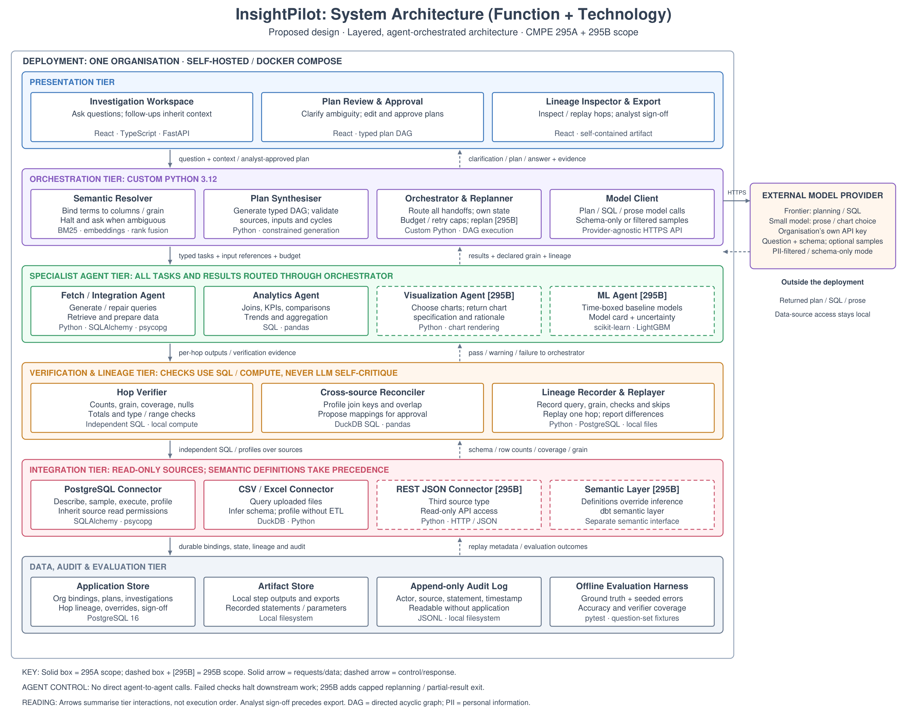
Architectural style. InsightPilot uses a layered architecture of six tiers, deployed for a single organisation. Generation and verification are kept apart: components that produce an answer may call a language model, and components that check an answer may not. Checks run as SQL or local computation, so they cannot share the failure mode of the model whose output they check. Two rules apply across the figure. All tasks and results pass through the orchestrator, with no direct agent-to-agent calls, so every handoff is observable, budgeted and recorded. And the arrows show which tiers interact, not the order of execution: each hop is verified as soon as it completes, not once at the end of the plan.
Presentation tier (React, TypeScript, FastAPI). The investigation workspace is where the analyst asks a question; follow-up questions inherit its context. Plan review and approval is where ambiguous terms are clarified and the plan is edited and approved before anything runs, so a wrong plan costs one edit rather than a wrong answer. The lineage inspector replays individual hops and exports the signed-off investigation as one self-contained file.
Orchestration tier (Python 3.12). The semantic resolver maps business terms to columns and grain, combining BM25 keyword search over column names and comments with embedding search and with matches against sampled values. When candidates score too closely or disagree on grain, it stops and asks instead of guessing, because a wrong guess produces the silent semantic errors described in the Literature Search [4]. The plan synthesiser uses constrained generation to produce a typed plan, a directed acyclic graph of steps, and validates its sources, inputs and dependencies before execution. Writing the orchestrator ourselves, rather than using an agent framework, keeps the plan an explicit data structure that can be shown, edited, approved and cached. The orchestrator dispatches every task, holds execution state, and enforces budgets and retry limits; replanning after a failed check is CMPE 295B scope. The model client works with any provider and can send the schema only, or a filtered sample of values.
Specialist agent tier. The fetch and integration agent writes and repairs queries and prepares data. The analytics agent performs joins, aggregations, KPIs, trends and comparisons in SQL and pandas. Two agents are planned for CMPE 295B: a visualization agent that returns a chart specification with its rationale, and a machine-learning agent that builds time-boxed baseline models with a model card and an uncertainty statement.
Verification and lineage tier. The hop verifier checks row counts, grain, coverage, nulls, totals and value ranges on each hop with independent SQL. The cross-source reconciler profiles join keys and value overlap and proposes a mapping for the analyst to approve, since mapping one region code to another is a business decision. The lineage recorder stores each hop's query, grain and check results, including checks that were skipped, and can replay a single hop and report differences. A failed check stops downstream work.
Integration tier (read-only). The PostgreSQL connector describes, samples, queries and profiles a database using the source's own read permissions. The CSV and Excel connector queries uploaded files through DuckDB, inferring and profiling their schema without an ETL step. A REST JSON connector and dbt semantic-layer support follow in CMPE 295B; semantic-layer definitions, when present, override inferred bindings.
Data, audit and evaluation tier. PostgreSQL 16 stores bindings, plans, investigations, hop lineage, overrides and sign-off. Recorded statements, step outputs and exports are kept on the local filesystem. An append-only JSONL audit log records the actor, source, statement and time of every query, and can be read without the application. The offline evaluation harness runs the question set and the seeded-error set under pytest to produce the published accuracy and verifier-coverage figures.
External model provider. Only model calls leave the deployment. A frontier model handles planning and SQL generation, and a smaller model writes prose (and, in CMPE 295B, chooses charts), using the deploying organisation's own API key. Requests carry the question and schema, with optional samples; a PII-filtered or schema-only mode is available. Data-source access never leaves the deployment.
One investigation, end to end. The analyst asks a question that spans a warehouse table and an uploaded CSV. The resolver asks once which of two columns means "region", and the synthesiser produces a plan that passes validation. The analyst narrows one fetch and approves the plan. The orchestrator sends the first task to the fetch agent, and the verifier checks its counts, grain and coverage before the next task starts. The coverage check finds 8% of region codes unmatched; the analyst accepts the proposed mapping, which is saved as a binding. The analytics agent then joins and aggregates, with each hop verified. The answer arrives with a note naming the least certain hop, and after sign-off the investigation is exported as one file.
Deployment. Each organisation runs its own copy with Docker Compose, which is also the basis of the 30-minute quickstart. There is no shared multi-tenant service.
Implementation update (Workbook 2). The structure of the architecture is unchanged. Two details were settled during design and implementation: the orchestrator also composes the final answer, calling the small model through the model client to write established facts from verified hops only; and the plan synthesiser was first tested with direct calls to the Claude API, with the model client and its runtime environment built in Sprint 4. The as-built status of every component is shown in Chapter 6, Figure 2.

Project Design
This chapter documents the design of InsightPilot for both semesters: the design methodology, the status of each architecture component as of November 12, 2026, three UML class diagrams (the domain model, the services and the answer presentation), a UML sequence diagram of one question, and the database design. The class, sequence and database diagrams describe the complete design whether or not a part has been built; build status is shown only in Figure 2 and Table 9.

Design Methodology
The design follows three working rules. First, the plan is data: the plan synthesiser produces a typed directed acyclic graph of steps, which can be validated, shown, edited, approved and cached before any query runs. Second, interfaces come before implementations: the source connector interface (describe, sample, execute, profile), the step result every agent returns and the hop record are fixed first, so each member builds against a contract while other components are still in progress. Third, each feature is delivered as a thin vertical slice, from the investigation workspace through the orchestrator and agents to the database, and deepened in later sprints. Five principles guide every component:
- Generation and verification are separate. Components that produce an answer may call a language model; components that check one may not. The hop verifier and the cross-source reconciler issue independent SQL, so a check cannot share the failure mode of the output it checks.
- Every handoff goes through the orchestrator. Agents never call each other. Each step goes out as a task and returns as a step result, which makes every hop observable, budgeted and recorded.
- Agents think and act inside one approved step. Each specialist agent is a language-model tool-use loop: it reasons through the model client, acts through the source connector, observes the result and repairs its query, read-only and within a retry cap.
- There is one route to the model. The model client is the only component that calls a language model. It routes plans and SQL to a frontier model and answer prose to a small model, enforces schema-only or filtered-sample mode, and counts cost against the investigation’s budget.
- Humans gate the irreversible points. Ambiguous terms are clarified and the plan is approved before any query runs, and an analyst signs off before an answer is exported.

As-Built Component Design
- As-built status of each architecture component (November 12, 2026)
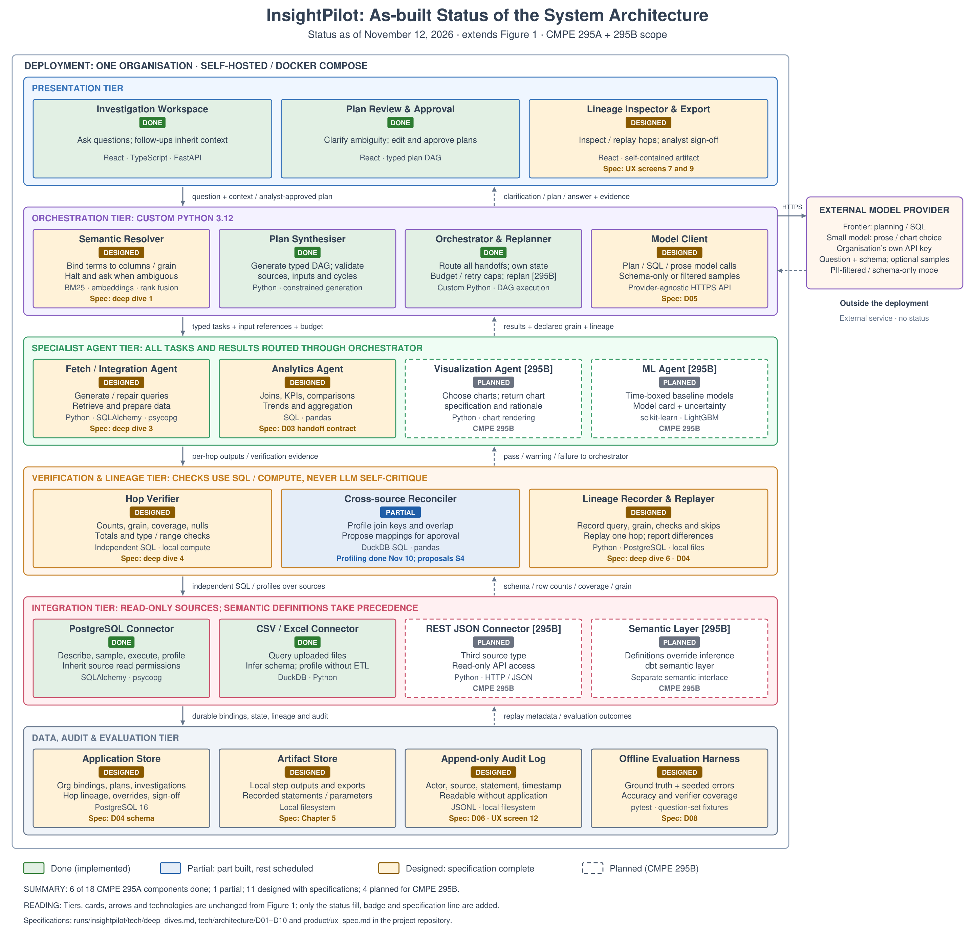
Figure 2 marks each component of Figure 1 with its status. Six of the eighteen CMPE 295A components are done: the investigation workspace, plan review and approval, the plan synthesiser, the orchestrator, and the PostgreSQL and CSV/Excel connectors. The cross-source reconciler is partial: key profiling is done and the transform search and mapping proposals are built in Sprint 4. The other eleven are designed, each with a specification in the project’s design documents, and the four CMPE 295B components are planned. Table 9 lists every component with its responsibility, the specification it is built from and its owner; specifications refer to the deep dives, the architecture diagrams D01–D10 and the UX specification in the project repository.
- Component design: responsibility, specification, owner and status
Component | Responsibility | Specification | Owner | Status
Investigation Workspace | Ask questions; follow-ups inherit context; show live hop panels and the answer | UX spec §1, §6 | SZ | Done
Plan Review & Approval | Clarify ambiguous terms; edit and approve the plan before anything runs | UX spec §2, §4; D10 | SZ | Done
Lineage Inspector & Export | Inspect and replay hops; analyst sign-off; export one self-contained file | UX spec §7, §9 | SZ | Designed
Semantic Resolver | Bind business terms to columns and grain; halt and ask when ambiguous | Deep dive 1 | AK | Designed
Plan Synthesiser | Generate the typed plan DAG; validate sources, inputs and cycles | Deep dive 2 | AK | Done
Orchestrator & Replanner | Dispatch every step; hold state, budget and retry caps; compose the answer; replan [295B] | D02, D03 | AK | Done
Model Client | Single route to the language model: model routing, data-egress mode, cost tracking | D05, D06 | AK | Designed
Fetch / Integration Agent | Write and repair SQL against sources; return a step result | Deep dive 3 | AN | Designed
Analytics Agent | Joins, aggregations, KPIs and comparisons over earlier step outputs | D03 | PS | Designed
Visualization Agent [295B] | Choose a chart; return a chart specification and its rationale | D03 | SZ | Planned (295B)
ML Agent [295B] | Time-boxed baseline models with a model card and uncertainty | Deep dive 7 | AK (build), PS (evaluation) | Planned (295B)
Hop Verifier | Row-count, grain, coverage, null, total and range checks per hop, in SQL | Deep dive 4 | PS | Designed
Cross-source Reconciler | Profile join keys and overlap; propose mappings for analyst approval | Deep dive 5 | PS (lead), AN (profiling) | Partial: profiling done; proposals S4
Lineage Recorder & Replayer | Record each hop; replay one hop against current data and report differences | Deep dive 6; D04 | SZ | Designed
PostgreSQL Connector | Describe, sample, execute and profile, read-only, with the source’s own permissions | D07 | AN | Done
CSV / Excel Connector | Query uploaded files through DuckDB; infer and profile their schema | D07 | AN | Done
REST JSON Connector [295B] | Third source type; read-only API access | D07 | AN | Planned (295B)
Semantic Layer [295B] | dbt definitions that take precedence over inferred bindings | D07 | AN | Planned (295B)
Application Store | Bindings, plans, investigations, hops, overrides and sign-off (PostgreSQL 16) | D04 | AN | Designed
Artifact Store | Full step outputs and exports, addressed by hash | Chapter 5 | AN | Designed
Append-only Audit Log | Every statement issued to every source; readable without the application | D06; UX spec §12 | SZ | Designed
Offline Evaluation Harness | Fixed question set and seeded errors; accuracy and verifier coverage | D08 | PS | Designed

Domain Model (UML Class Diagram)
Figure 3 shows what the system stores. An organisation owns its sources, its bindings and its investigations; there is one organisation per deployment. An investigation holds the analyst’s questions; each question is planned as a plan of steps and answered by an answer made of blocks. The model card is CMPE 295B scope. Four classes carry the design:
- Binding. What a business term means in the data, with its provenance (semantic layer, analyst-confirmed, inferred or stakeholder-unconfirmed) and schema version, so a confirmed meaning is reused rather than guessed again. An approved mapping proposal from the reconciler becomes a join binding.
- Plan and PlanStep. The typed directed acyclic graph the analyst approves; each step names its type, source, bindings and declared grain, and lists the steps it depends on.
- Hop. The record of one executed step: the exact statement, row counts, declared and actual grain, retry attempts and a reference to its full output. It can be replayed against current data and may carry an analyst’s override.
- HopVerdict and CheckResult. Each verification attempt on a hop is a HopVerdict (PASS, WARN, FAIL or ERROR) holding one CheckResult per check with its status (PASS, WARN, FAIL, SKIP or ERROR), expected and observed values, tolerance and exact SQL. A re-run adds a new verdict instead of overwriting the old one, so differences stay visible.
- Answer and AnswerBlock. The reply to a question, made of ordered blocks that cite the hops they came from, and signed off by an analyst before export.

- UML class diagram of the core domain model
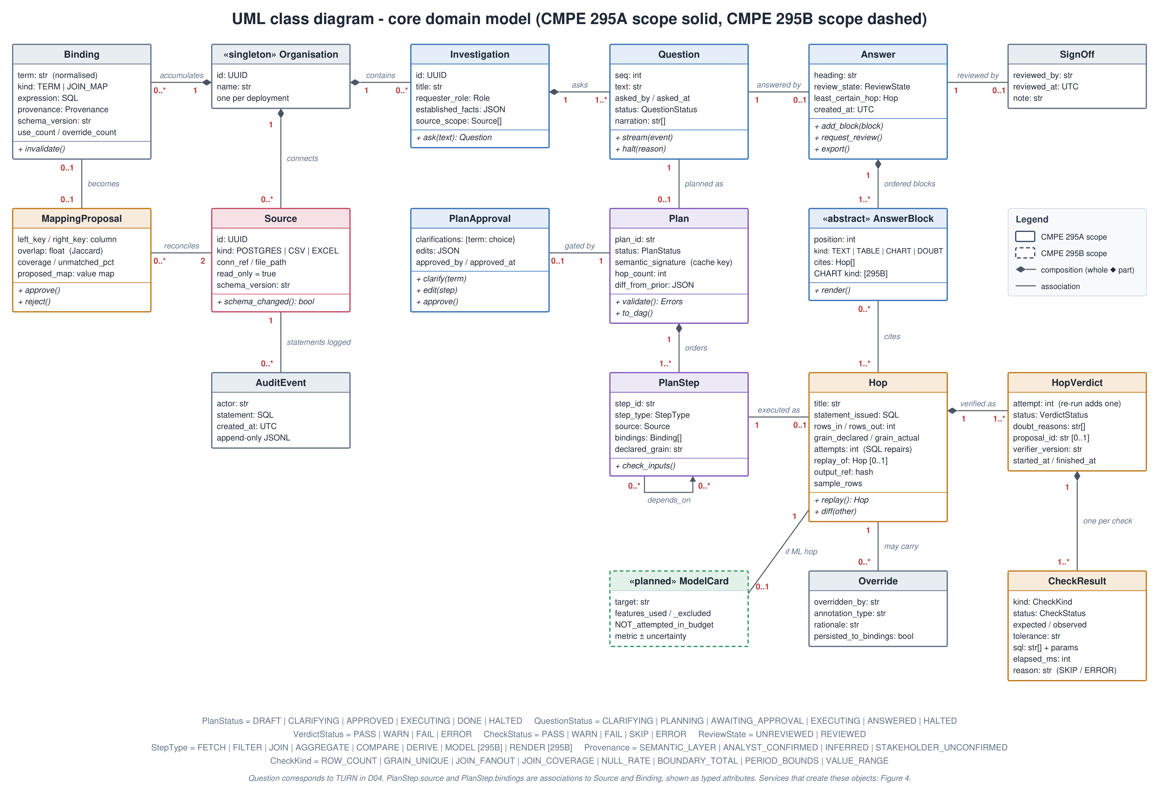

Services (UML Class Diagram)
Figure 4 shows which component does the work and which objects of Figure 3 it creates. The orchestrator is the hub: every step goes out through it and every result comes back to it, and agents never call each other. Grey boxes in the figure are domain classes from Figure 3.
- Orchestrator. Invokes the semantic resolver and the plan synthesiser, waits for plan approval, dispatches each step to a specialist agent, receives the step result, passes it to the hop verifier and the lineage recorder, and finally composes the answer.
- SemanticResolver and PlanSynthesiser. Create bindings and the plan. A dbt semantic supplier (CMPE 295B) provides definitions that take precedence over inferred ones.
- SpecialistAgent. Fetch and analytics agents (visualization and ML in CMPE 295B). Each reasons through the model client, acts through the source connector, repairs a failed query, and returns a step result.
- ModelClient. The only component that calls a language model: plans and SQL go to a frontier model, answer prose to a small model, under schema-only or filtered-sample mode.
- SourceConnector. One read-only interface (describe, sample, execute, profile) implemented for PostgreSQL and CSV/Excel, with REST JSON in CMPE 295B; it writes every statement to the audit log.
- HopVerifier, CrossSourceReconciler and LineageRecorder. Produce hop verdicts with their check results, mapping proposals and hops. The first two issue independent SQL built from the approved plan step, not from the agent’s SQL, and never call a model.

- UML class diagram of the services
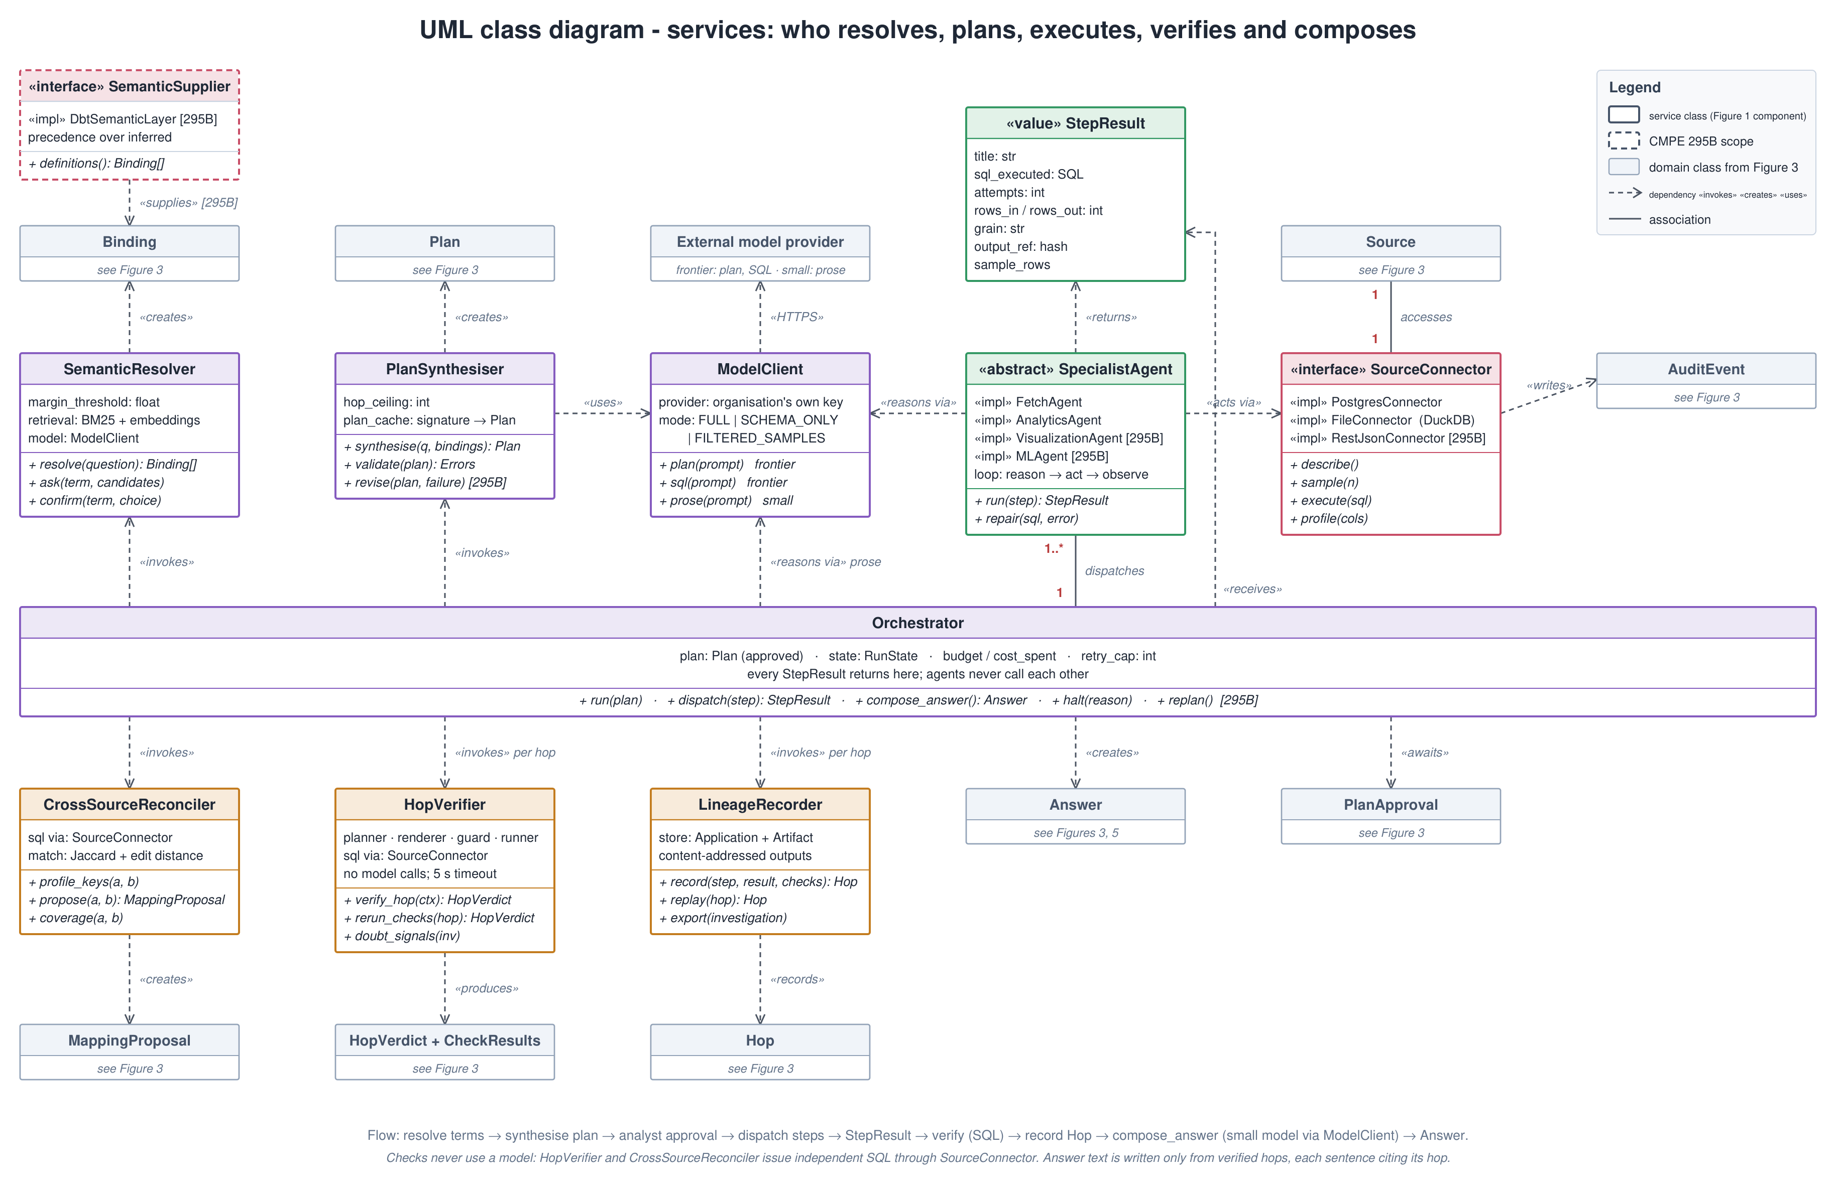

Answer Presentation (UML Class Diagram)
Figure 5 expands the answer the analyst sees in the investigation workspace. An answer is an ordered list of blocks, each a subclass of AnswerBlock, and every claim carries a citation to the hop that produced it, so opening a footnote shows that hop’s statement, row counts and checks.
- TextBlock. The summary and key insights, written by the small model using only numbers from verified hops.
- TableBlock. The actual rows of a hop’s output, read from the artifact store; no model rewrites them.
- DoubtBlock. A WARN or FAIL check from the hop verifier, naming the hop, the check and the reason, so the least certain step is visible in the answer itself.
- ChartBlock and ChartSpec. A chart with its type, axes, colour grouping and rationale, produced by the visualization agent; CMPE 295B scope.

- UML class diagram of the answer presentation
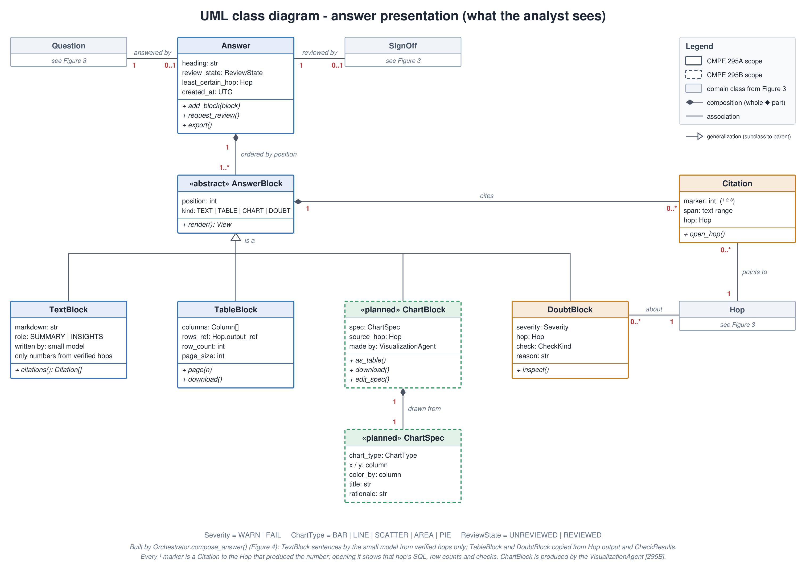

Key Interaction (UML Sequence)
Figure 6 follows one question. The orchestrator resolves the question’s terms, has the plan synthesised and shows it for approval (steps 1–8). For each step in DAG order it dispatches the step to an agent, which writes SQL through the model client and executes it read-only; the step result returns to the orchestrator, which has it verified and recorded as a hop (steps 9–15). When every hop has passed, the orchestrator has the small model write the insight text from verified facts and returns the answer for sign-off (steps 16–18). Four paths are omitted from the figure for readability:
- Clarification. If two candidate meanings of a term score within the margin, the resolver halts and the analyst chooses; the choice is saved as a binding and never asked again.
- SQL repair. If a query fails, the agent returns the database error to the model and retries, up to the orchestrator’s retry cap.
- Cross-source reconciliation. When a step joins two sources, the reconciler profiles both keys and proposes a mapping with its coverage; the analyst approves it before use.
- Halt on red. If any check fails, the remaining steps are skipped and the analyst sees the partial result and the failing hop.

- UML sequence diagram of answering one question (main path)
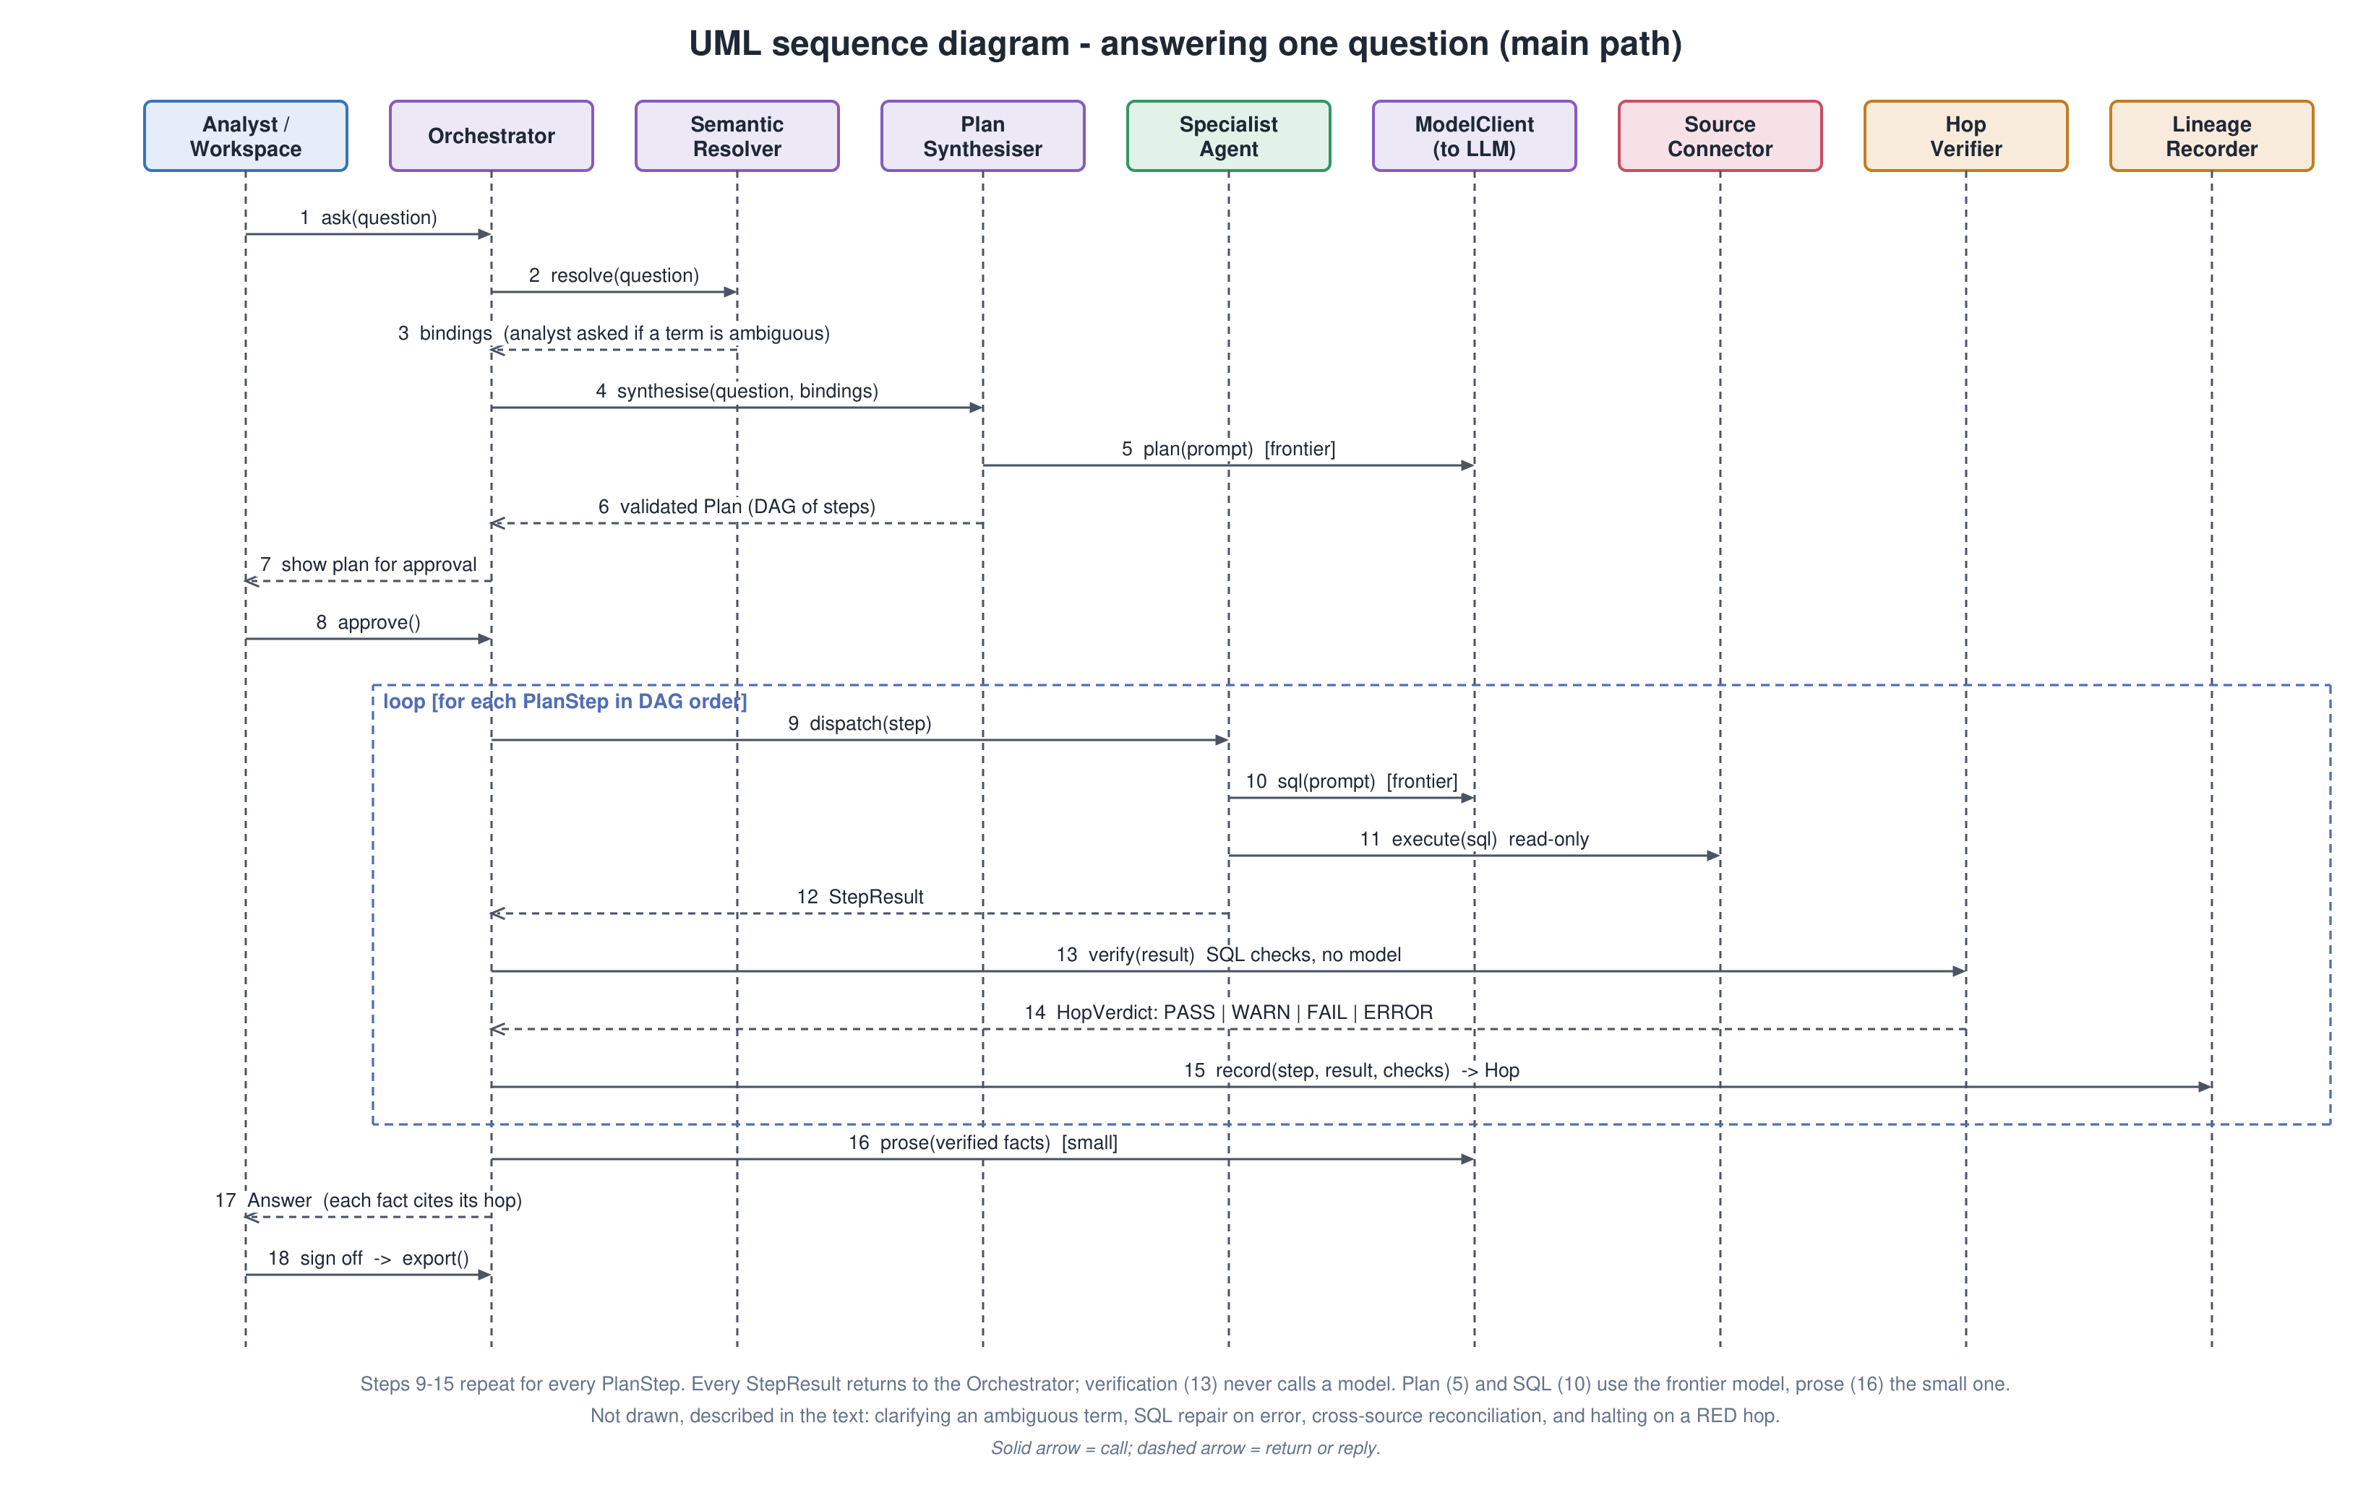

Database Design
Figure 7 shows the Application Store. All durable state lives in one PostgreSQL 16 database per deployment: twenty-one tables, one of them (model_cards) CMPE 295B scope, including three tables written by the evaluation harness. Uniqueness constraints enforce correctness in the database itself: one question number per investigation, one step key per plan, one block position per answer and one verdict per hop attempt; verdicts are never updated, so a re-run inserts a new attempt. Full result sets are not stored: a hop keeps its row counts, grain and a sample, and the full output is a file in the artifact store addressed by the hop’s output reference, because a re-run against current data is the point of replay. The audit log is an append-only JSONL file, readable without the application, and credentials never enter any table.

- Entity-relationship diagram of the Application Store (PostgreSQL 16)
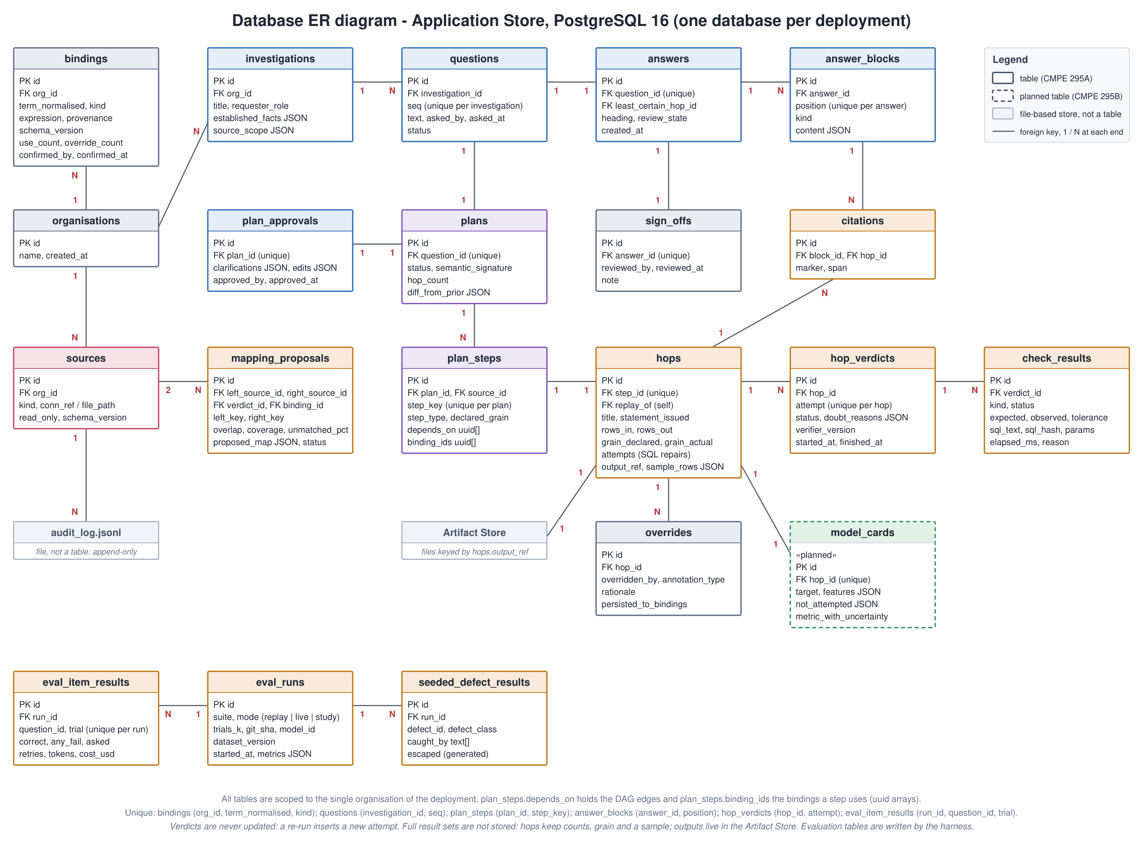

UI Design
Figure 8 shows the investigation workspace, the screen in which an analyst works (mockup by Pranjal Shrivastava, sample data). Its layout follows the conversational pattern analysts already know from tools such as Databricks Genie: a context rail on the left and the conversation on the right. Each element maps to a class of Figures 3 to 5:
- Context rail. Investigations with their review state (signed off or awaiting review), the connected sources (the read-only warehouse and an uploaded file), the bindings in scope with their provenance, and links to the review queue, the audit log and the settings (schema-only mode and the budget cap). Classes: Investigation, Source, Binding, SignOff, AuditEvent.
- Question, clarification and plan. The question, the term the analyst clarified and saved as a binding, and the approved plan with its steps, collapsed after approval. Classes: Question, PlanApproval, Plan, PlanStep.
- Executed steps. One collapsible row per hop with its verdict, sources, rows in and out, grain and SQL attempts; an expanded step shows the generated SQL, a result preview and each check with its expected and observed values, plus replay. Classes: Hop, HopVerdict, CheckResult.
- Answer. An amber banner until an analyst signs off; the summary and key insights with a citation to the step behind each number; the result table; the chart (CMPE 295B); the least certain step; actions to inspect lineage, correct a step or export (enabled only after sign-off); feedback; and suggested follow-ups. Classes: Answer, TextBlock, Citation, TableBlock, ChartBlock, DoubtBlock, SignOff, Override.
Four elements set the screen apart from a generic chat-with-data interface and carry the project’s argument: the plan is approved before anything runs, every step shows its verification, every claim cites the step it came from, and export waits for an analyst’s sign-off.

- UI mockup of the investigation workspace (sample data)
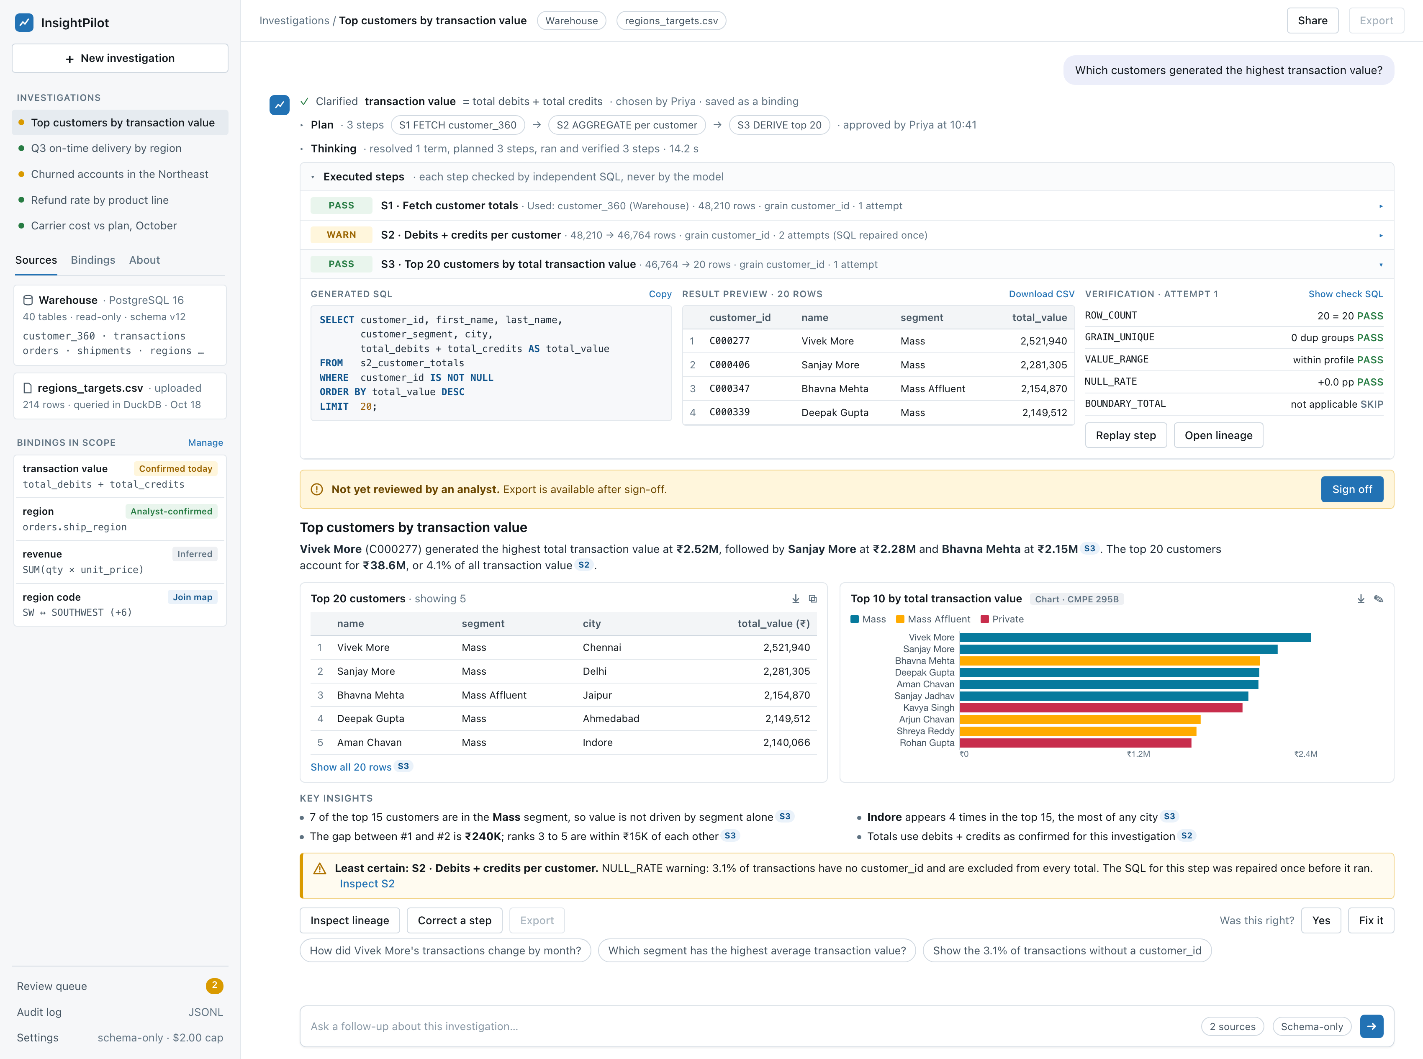

QA, Performance, Deployment Plan

Quality Assurance Strategy
Testing follows a test pyramid with automated gates on every pull request. The evaluation harness, built before the agents, is itself a CI job, so accuracy is measured on every change rather than once. Table 10 lists each test level with its scope, tools, CI job and owner, and the Chapter 3 requirements it verifies; together the rows cover every functional and non-functional requirement. Requirements marked * are Desired or Optional and are tested in CMPE 295B when the feature is built. Figure 9 shows where each level runs.
- Test levels, tools and CI gates
Level | Scope | Tools | CI job | Requirements covered | Owner
Static analysis | Lint, formatting and strict typing for Python and TypeScript | ruff, mypy --strict, tsc, eslint | lint | NFR-14 | All
Unit and contract | Plan schema and static validation, binding resolution and reuse, follow-up context, plan cache key; contracts for the step result, the hop record and the connector interface | pytest | unit | FR-05, FR-07, FR-08, FR-17, FR-23*, NFR-14 | AK, AN
Integration | Connectors against real PostgreSQL 16 and DuckDB in Docker: read-only enforcement, inherited permissions, file schema inference, audit log | pytest, Docker Compose | integration | FR-03, FR-04, FR-16, FR-20*, FR-21*, NFR-01, NFR-03, NFR-05 | AN
Agent end-to-end | Question to answer through the orchestrator, agents, verifier and recorder with recorded model responses; replay, override and replanning | pytest, recorded model fixtures | agent-e2e | FR-09, FR-10, FR-11, FR-13, FR-15, FR-18*, FR-19*, FR-24*, FR-25*, NFR-06, NFR-07 | AK, PS
Evaluation harness | Fixed question set and seeded-error set through the full pipeline: accuracy, silent errors, verifier coverage, pass^k, attempts and cost | pytest, Docker Compose | harness | FR-01, FR-02, NFR-08, NFR-12 | PS
UI end-to-end | Ask, clarify, approve, inspect a hop, export and sign off in the browser; accessibility checks | Playwright, axe-core | web | FR-06, FR-12, FR-14, FR-22*, FR-26* | SZ
Security and privacy | Secret, dependency and image scans; write-attempt probes on every agent path; sensitive columns kept out of model context; no write or alert tools exposed | gitleaks, dependency and image scanners | security | NFR-02, NFR-04, NFR-15 | AN, SZ
Performance and cost | Plan latency on the reference schema; tokens, attempts and cost per investigation | harness timers, model-client usage records | harness (nightly) | NFR-11, NFR-12 | AK
Deployment | Clean-checkout quickstart, timed on a fresh machine | Docker Compose | release | FR-27*, NFR-13 | AN
Human evaluation | Verification-cost study and seeded-defect review with analysts; usability walkthrough | moderated, timed sessions | none (Dec 7–11) | NFR-09, NFR-10 | PS, SZ

- Evaluation and CI pipeline
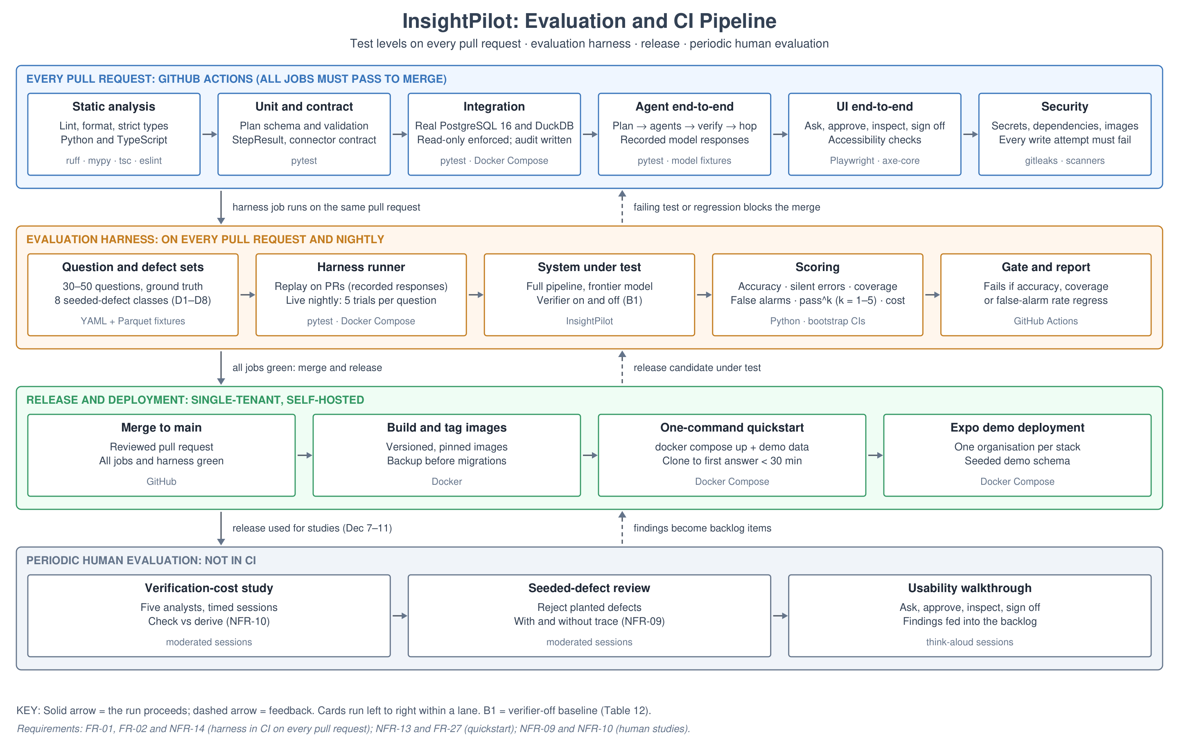

Evaluation Methodology
The evaluation answers six research questions. Each has a metric, an explicit baseline and an acceptance threshold from the requirements in Chapter 3.
- Research questions, metrics and baselines
Research question | Metric | Baseline | Target (Chapter 3) | Status
RQ1. How often are multi-hop questions answered correctly? | Execution accuracy on the fixed question set | B2: single-shot text-to-SQL on the same questions; DABstep Hard 14.55% for context only [6] | Measured and published (NFR-08) | Harness S1–S4; first figure Nov 22 (SP-6)
RQ2. Do per-hop checks catch plausible wrong answers? | Silent-error rate; verifier coverage per defect type | B1: the same pipeline with the hop verifier off | Coverage reported per defect type (FR-02) | Protocol ready; measured S5
RQ3. Are answers stable across repeated runs? | pass^k for k = 1–5 from five live trials [8] | B3: pass@1 of the same system | Reported alongside accuracy | Measured S5
RQ4. Is checking an answer cheaper than deriving it? | Verification cost ratio | B4: the analyst derives the answer unaided | Median below 0.5; above 0.8 is a stop trigger (NFR-10) | Study Dec 7–11
RQ5. Does the trace help analysts reject wrong answers? | Share of seeded defects rejected | B5: the same answers without the trace | At least 70% and twice the control (NFR-09) | Study Dec 7–11
RQ6. What does an investigation cost, and how fast is the plan? | Cost by retry count; time to present the plan | Cost model: about $1.10 per six-hop investigation at one attempt | Cost reported (NFR-12); plan within 15 s (NFR-11) | Measured S4–S5

Setup. A dedicated harness starts its own Docker Compose project from empty volumes, loads the synthetic reference schema (orders, shipments, customers and regions across roughly 40 tables) into PostgreSQL 16 and the unmodelled CSV file into DuckDB, and runs every question of the fixed set (30–50 questions with authored ground truth, covering single-source, cross-source and ambiguous-term cases) through the full pipeline. On every pull request it runs in replay mode: model responses are read from recorded files, so the run is deterministic and costs nothing, and a missing recording fails loudly rather than calling the model. Nightly and before milestones it runs live, five trials per question, under a spend cap. Execution accuracy compares the answer table with the ground truth after matching columns and allowing a small numeric tolerance. No customer data is used.

Baseline B1: Verifier On Versus Verifier Off
The project’s central claim is that independent per-hop checks catch plausible wrong answers that a single-pass system would deliver. Baseline B1 tests that claim directly by running the seeded-error set twice, with and without the hop verifier. Table 12 defines the protocol so that a separate test team could run it.
- Baseline B1 protocol: verifier on versus verifier off
Item | Protocol
Question | Does the hop verifier catch plausible wrong answers that would otherwise reach the analyst?
Data | The seeded-error set: each investigation in the fixed set with one planted defect from eight classes: D1 wrong join key, D2 fan-out join, D3 wrong grain, D4 off-by-one period boundary, D5 wrong code mapping, D6 dropped filter, D7 null handling and D8 wrong measure. Each is labelled with its class and the hop where it was planted.
Treatment | The full pipeline with the hop verifier and the cross-source reconciler on.
Baseline B1 | The same pipeline, model and approved plans with the verifier switched off; every hop is recorded as unchecked.
Metrics | Silent-error rate: defects that reach the answer with no WARN or FAIL on any hop. Verifier coverage: defects flagged by at least one check, reported per defect type and per check.
Analysis | Paired caught and escaped outcomes per defect compared with McNemar’s test; rates reported with 95% bootstrap confidence intervals.
Decision rule | A defect class with low coverage gets a new check in CMPE 295B or is listed in the answer’s doubt block as not checked. D8 can pass every structural check and is expected to escape often; it is reported separately rather than hidden. Results are published even if negative.

Status and decision. No results exist yet: the harness and the seeded-error set are the first prototype increments, and the first figures are due with SP-6 on November 22. The outcome decides which checks are strengthened in CMPE 295B, and a negative result is reported rather than hidden.

Requirement Targets
Table 13 is the acceptance checklist for the measurable requirements. Each row names the target from Chapter 3 and exactly how it is measured; the result column records the sprint in which the measurement first runs and is replaced by the measured value when it does.
- Requirement targets and how each is measured
Metric | Target | How measured | Result
Plan presented after the question | Within 15 s for a six-hop plan (NFR-11) | Harness timer from question to plan shown on the reference schema; p50 and p95 over the question set | Planned (S4)
Statements in the audit log | 100% (NFR-05) | Compare every statement the connector logged with the database’s own statement log for a harness run | Planned (S4)
Write attempts from any agent path | None succeed (NFR-01) | Probe every agent path with DDL and DML; each must be rejected by the connector and by the database role | Planned (S4)
Model calls during verification | Zero (NFR-06) | Count model-client calls attributed to the hop verifier and the reconciler during a harness run | Planned (S4)
Replay of a recorded hop | Same result, or the difference reported (NFR-07) | Replay every hop of a harness run and compare output hashes | Planned (S4)
Execution accuracy | Measured and published (NFR-08) | Harness over the fixed question set: replay on every pull request, five live trials nightly | Planned (S4, SP-6)
Verification time per hop | Median 1.5 s or less, p95 5 s or less (refines NFR-11) | Verifier timing per check kind over the question set in replay mode | Planned (S4)
Seeded defects rejected by analysts | At least 70% and twice the control (NFR-09) | Moderated study, with and without the trace | Planned (Dec 7–11)
Verification cost ratio | Median below 0.5; above 0.8 stops (NFR-10) | Timed study with five analysts | Planned (Dec 7–11)
Cost per investigation | Reported by retry count (NFR-12) | Model-client token usage times provider price, grouped by attempts | Planned (S4–S5)
Clone to first investigation | Median under 30 min (NFR-13) | Fresh-machine quickstart, timed, by a member who did not write it | Planned (S5)
Back-end unit-test coverage | At least 70%; harness on every pull request (NFR-14) | Coverage report in CI | Planned (S4)

Evaluation Procedure
- Accuracy. Every question runs once per replay run and five times per nightly live run; execution accuracy is the share of answers that match the ground truth, reported per run and on every pull request, and compared with the single-shot baseline B2 on the same questions.
- Silent errors and coverage. The seeded-error set runs with the verifier on and off (Table 12); each defect is scored as caught or escaped, per defect type and per check.
- Consistency. pass^k for k = 1–5, estimated from the five live trials, is the chance of answering a question correctly in all k trials [8], reported next to accuracy because a system that is right on average can still be unreliable.
- Cost and latency. Tokens and attempts come from the model client’s usage records and plan latency from the harness timer; cost is reported grouped by retry count.
- Human studies. Five analysts each derive one answer unaided and check another produced by InsightPilot, in counterbalanced order, giving the verification cost ratio; in a second task they accept or reject answers containing seeded defects, with and without the trace.
- Statistics. Rates are reported with 95% bootstrap confidence intervals, paired pass and fail outcomes are compared with McNemar’s test, and every result is published, including negative ones.

Deployment Plan
Four environments are used: local development (Docker Compose on each member’s machine), continuous integration (GitHub Actions running every test level and the harness on each pull request), the harness environment (an isolated Compose project started from empty volumes, also run nightly) and the Expo demo (a single-tenant deployment of the tagged release with seeded demo data). There is no shared multi-tenant service: each organisation runs its own copy, so a release is a set of versioned, pinned images plus the Compose file and the one-command quickstart (NFR-13). Database changes ship as forward-only, versioned migrations applied after an automatic backup of the application store, and rollback redeploys the previous image tags and restores that backup. Credentials are supplied as environment secrets at deploy time and never enter the images, the database or the audit log (NFR-02).

Implementation Plan and Progress
Implementation starts with measurement. The team builds the evaluation harness and the fixed question set before any agent, then gets one narrow path working end to end: connect a source, plan a question, run two hops, verify them, record lineage and export the result. Each component is deepened only after that path works, because a system with several agents and no measurement cannot show whether it works. The early prototype demo requested by the advisor (deliverable 15) is a walkthrough of this first path on a relational database source.
Status at Workbook 2 (November 12, 2026). Six of the eighteen CMPE 295A components are done: the investigation workspace, plan review and approval, the plan synthesiser, the orchestrator, and the PostgreSQL and CSV/Excel connectors; the cross-source reconciler is partial (key profiling done, transform search and mapping proposals in Sprint 4). The plan path now works end to end: a question becomes a typed, validated plan that the analyst reviews and approves. The plan synthesiser was tested with direct calls to the Claude API; the model client that will take over those calls reads the provider key from the runtime environment, so it is built in Sprint 4 together with that environment. The execute, verify and record path (the specialist agents, the hop verifier and the lineage recorder) is designed and scheduled for Sprint 4; when it lands, the narrow vertical slice is complete. Orchestrator dispatch and reconciler profiling, planned for Sprint 4, are already done, and spikes SP-4 and SP-5 moved into Sprint 4 alongside the components they exercise. Changes since Workbook 1 are shown in bold in this chapter and in Chapter 9.

Programming and Execution Environment
- Programming and execution environment
Layer | Technology (version) | Purpose | Owner | Status
Source control and CI | GitHub repository, GitHub Actions | Code hosting, pull-request review, harness run on every pull request | AN | Repository created; CI running on every pull request since Oct 4
Language and runtime | Python 3.12 | All orchestration, agent and verification code | AK | Installed and verified by all four members
Orchestrator | Custom typed plan DAG (no agent framework) | The plan must be validatable, diffable and cacheable | AK | Done: typed plan DAG, dispatch, budget and retry caps
Model access | Provider-agnostic client; project API key | Planning, term resolution and SQL generation | AK | Plan synthesiser tested with direct Claude API calls; model client designed (Chapter 6), built in S4 with the runtime environment
Database access | SQLAlchemy, psycopg | Read-only Postgres introspection and execution | AN | Done: read-only PostgreSQL connector
File and CSV engine | DuckDB | Query CSV, Excel and Parquet directly with no ETL step | AN | Done: CSV / Excel connector
Profiling | DuckDB SQL, pandas | Cardinality, uniqueness, overlap and null-rate profiling | PS | Done: reconciler key profiling
Application store | PostgreSQL 16 | Bindings, investigation records, sign-off state | AN | Schema designed (Figure 7); tables built in S4
Audit log | Append-only JSONL on disk | Readable without the application running | SZ | Designed; built in S4
API and front end | FastAPI, React, TypeScript | Investigation surface, plan review, lineage inspector | SZ | Done: investigation workspace and plan review
Modelling (295B) | scikit-learn, LightGBM | Time-boxed baseline models within a minutes budget | PS | CMPE 295B
Packaging | Docker, Docker Compose | Reproducible local stack; later the quickstart | AN | Done: Docker Compose stack since Oct 4
Harness | pytest with a question-set fixture | Execution-accuracy and seeded-error measurement | PS | Designed (Chapter 7); first run Nov 22 (SP-6)

Development Tools per Team Member
- Development tools acquired per member (all installed and verified)
Tool | Atharva Kulkarni | Akshay Navani | Pranjal Shrivastava | Shantanu Zadbuke
IDE with Python, TypeScript and Docker extensions | Yes | Yes | Yes | Yes
Python 3.12 toolchain and pytest | Yes | Yes | Yes | Yes
Docker Desktop and Docker Compose | Yes | Yes | Yes | Yes
PostgreSQL 16 locally or in Docker | Yes | Yes | Yes | Yes
DuckDB CLI and Python package | Yes | Yes | Yes | Yes
Frontier-model API key through the shared project account | Yes | Yes | Yes | Yes
Node and the front-end toolchain | Yes | Yes | Yes | Yes
Database client for schema inspection | Yes | Yes | Yes | Yes
GitHub Projects board for task tracking | Yes | Yes | Yes | Yes

Prototyping and Simulation Environment
The project is software-only, so the prototyping environment is a reproducible simulated analytics estate rather than hardware:
- Local stack. Docker Compose running PostgreSQL, the application services and the harness, so all four members run an identical environment. Status: in use by all four members since Oct 4.
- Reference schema. A synthetic dataset generated by the team and loaded into local Postgres, seeding orders, shipments, customers and regions across roughly 40 tables. It is wide enough to be realistic, because accuracy drops sharply on realistic schemas (see the Literature Search) and a narrow schema would flatter the system. Status: generated and loaded on Oct 18.
- Unmodelled source. A CSV file deliberately not represented in the warehouse schema, queried through DuckDB, so the evaluation always includes a cross-source question. Status: used to test the CSV / Excel connector and the reconciler.
- Fixed question set. 30–50 questions with authored ground truth covering single-source, cross-source and ambiguous-term cases. Status: designed (Chapter 7); built in S4 for SP-6.
- Seeded-error set. The same investigations with deliberately planted wrong joins, grains and region mappings, used to measure what escapes every check. Status: protocol defined (Table 12); built in S4.

Sample Programs and Technology Spikes
- Sample programs used to learn each technology (owner initials as in Table 7)
Spike | Goal and what it proves | Owner | Target
SP-1 Postgres read path | Connect read-only, introspect the schema, execute a parameterised query and return row counts and grain | AN | Oct 11, 2026 – Done (Oct 4)
SP-2 DuckDB file path | Query a CSV directly with SQL, infer and correct types, and join it to a Postgres result | AN | Oct 11, 2026; done Oct 18
SP-3 Typed plan object | One model call returns a plan that parses into the typed DAG and passes static validation; an invalid plan is rejected with field-level errors | AK | Oct 11, 2026; done Oct 18
SP-4 Hop verification | Run row-count, grain and coverage checks against a deliberately broken join and confirm the failure is caught and reported | PS | Oct 25, 2026; moved to S4 with the hop verifier
SP-5 Lineage record and replay | Record a hop, re-execute it from the record alone, and diff the result | SZ | Nov 8, 2026; moved to S4–S5 with the lineage recorder
SP-6 Harness run | Execute five questions end to end with ground-truth comparison and print an accuracy figure | PS | Nov 22, 2026 – on track

Prototype Implementation Plan
- Prototype increments for CMPE 295A
Step | Increment | Technologies exercised | Sprint
1 | Measurement first: repository, CI, harness skeleton, fixed question set with ground truth, seeded-error set | GitHub Actions, pytest, PostgreSQL | S1 – repository and CI done (Oct 4); harness and question sets moved to S4
2 | Source substrate: read-only Postgres connector and CSV/Excel ingestion with inferred schema | SQLAlchemy, psycopg, DuckDB | S1–S2 – Done
3 | Plan path: question to typed plan DAG, static validation, plan shown and approved | Provider-agnostic model client, Pydantic | S2–S3 – Done
4 | Execute path: fetch and analytics agents run approved steps and emit structured output | Python agents, SQL | S3; orchestrator dispatch done, agents in S4
5 | Verify path: hop verifier checks each step; failures surface at the hop that caused them | SQL checks, DuckDB | S3–S4; moved to S4
6 | Lineage path: hop records, readable hop view, single-hop re-run and diff | PostgreSQL, FastAPI, React | S4; S4–S5
7 | Export and audit: self-contained investigation artifact and append-only audit log | JSONL, templating | S4–S5; S5
8 | Grounding quality: ambiguity interception, binding store, doubt surfacing | BM25, embeddings, reciprocal rank fusion | S5
9 | Measure and report: execution accuracy, silent-error rate, verifier coverage, cost per investigation by retry count | Harness, seeded-error set | S5–S6

Work Completed Since Workbook 1
Table 18 lists the components finished since Workbook 1 against the sprint in which Workbook 1 scheduled them. Orchestrator dispatch and reconciler profiling were scheduled for Sprint 4.
- Work completed since Workbook 1
Component | Planned (Workbook 1) | Completed | Owner
Investigation workspace | S1 (skeleton) | S1 (Oct 4) | SZ
Wireframes | S1 | S1 (Oct 4) | PS (reassigned from SZ)
Plan review and approval | S2 | S2 (Oct 18) | SZ
Plan synthesiser (SP-3) | S2 | S2 (Oct 18) | AK
Orchestrator dispatch, budgets and retry caps | S4 | S4 (Nov 10) | AK
Cross-source reconciler profiling | S4 | S4 (Nov 10) | PS, AN
PostgreSQL connector (SP-1) | S1 | S1 (Oct 4) | AN
CSV / Excel connector (SP-2) | S2 | S2 (Oct 18) | AN

Progress Log
- Implementation progress
Date | Item | Status
Sep 14, 2026 | Project repository created with README, concept and roadmap | Done
Sep 2026 | Project concept and abstract agreed with the advisor | Done
Sep 2026 | Python 3.12 environment and dependencies installed and verified by all four members | Done
Sep–Oct 2026 | Literature search, state of the art, requirements and architecture (this workbook) | Done
Sep 28 – Oct 11, 2026 | Sprint 1: repository, CI, Docker Compose, harness skeleton, question set, spikes SP-1 to SP-3 | SP-1, CI and Docker Compose done (Oct 4); SP-2 and SP-3 done in Sprint 2 (Oct 18); harness skeleton and question set moved to S4
Oct 2026 | Design being finalised; spike started on the agentic flow for a relational database source | Done
Oct 12 – Oct 25, 2026 | Sprint 2: plan synthesis, CSV ingestion, ground truth and seeded errors, spike SP-4 | Plan synthesis and CSV ingestion done; ground truth, seeded errors and SP-4 moved to S4
Oct 26 – Nov 8, 2026 | Sprint 3: design for Workbook 2 (Chapters 6 and 7) completed Nov 1; semantic resolver, hop verifier and lineage view moved to S4 | Done
Nov 2026 | Workbook 2 design: as-built status, UML class, sequence and ER diagrams, test plan and evaluation protocol (Chapters 6 and 7); owners added for the fetch agent (AN), analytics agent (PS) and artifact store (AN); wireframes and UI mockups reassigned from SZ to PS | Done
Nov 9 – Nov 22, 2026 | Sprint 4: specialist agents, hop verifier (SP-4), lineage recorder (SP-5), model client, application store, harness and first accuracy figure (SP-6) | In progress

Project Schedule
The project runs in two-week sprints from 14 September 2026, when the project repository was created, through the end of CMPE 295B, and work is tracked on a GitHub Projects board. At the end of each sprint the team demonstrates what was merged and updates the progress log in Chapter 8. In every sprint each member owns a separate stream of work, so tasks do not overlap; the last two days of a sprint are reserved for joint integration. The early prototype demo requested by the advisor (deliverable 15) will be added to the schedule once its date is agreed.
For Workbook 2 the CMPE 295A sprints were re-planned. The source substrate, the plan path, orchestrator dispatch and reconciler profiling are done (Table 18). The measurement work (harness skeleton, question set and seeded-error set) and the Sprint 3 build items (binding store, semantic resolver, hop verifier and lineage view) moved into Sprint 4, so milestone M2 moves from November 8 to November 22; M3, M4 and the verification-cost study keep their dates, and the CMPE 295B sprints are unchanged. Owners were added for the fetch agent (AN), the analytics agent (PS) and the artifact store (AN), and the wireframes and UI mockups were reassigned from SZ to PS. Figure 10 shows the updated schedule, Table 21 the re-planned assignments, and Figures 11 and 12 the task dependencies and critical paths.

Milestones
- Milestones and exit criteria
Milestone | Date | Exit criteria
M1 Requirements and architecture baseline | Oct 8, 2026 – achieved | Literature search, requirements, architecture and schedule complete and reviewed with the advisor; Workbook 1 submitted
M2 Measurement baseline | Nov 8, 2026 → Nov 22, 2026 (harness and seeded-error set moved to S4) | Harness skeleton, fixed question set with ground truth, and seeded-error set complete; hop-check spike (SP-4) passes against a deliberately broken join
M3 Narrow path end to end | Dec 6, 2026 – on track | One question spanning Postgres and an uploaded CSV is planned, approved, executed, verified per hop and exported as a self-contained artifact
M4 Evidence for the central claim | Dec 11, 2026 – on track | Verification-cost study run with five analysts; silent-error rate and verifier coverage reported even if the result is negative
M5 Beta | Mar 7, 2027 – unchanged | Replanning, hop override, REST connector, dbt consumption, sign-off and export working on the staging environment
M6 Final release | May 7, 2027 – unchanged | Hardened system, published accuracy and coverage figures, paper draft, demo video and Expo prototype

- Project schedule by sprint and team member (updated for Workbook 2 with status and re-plan)
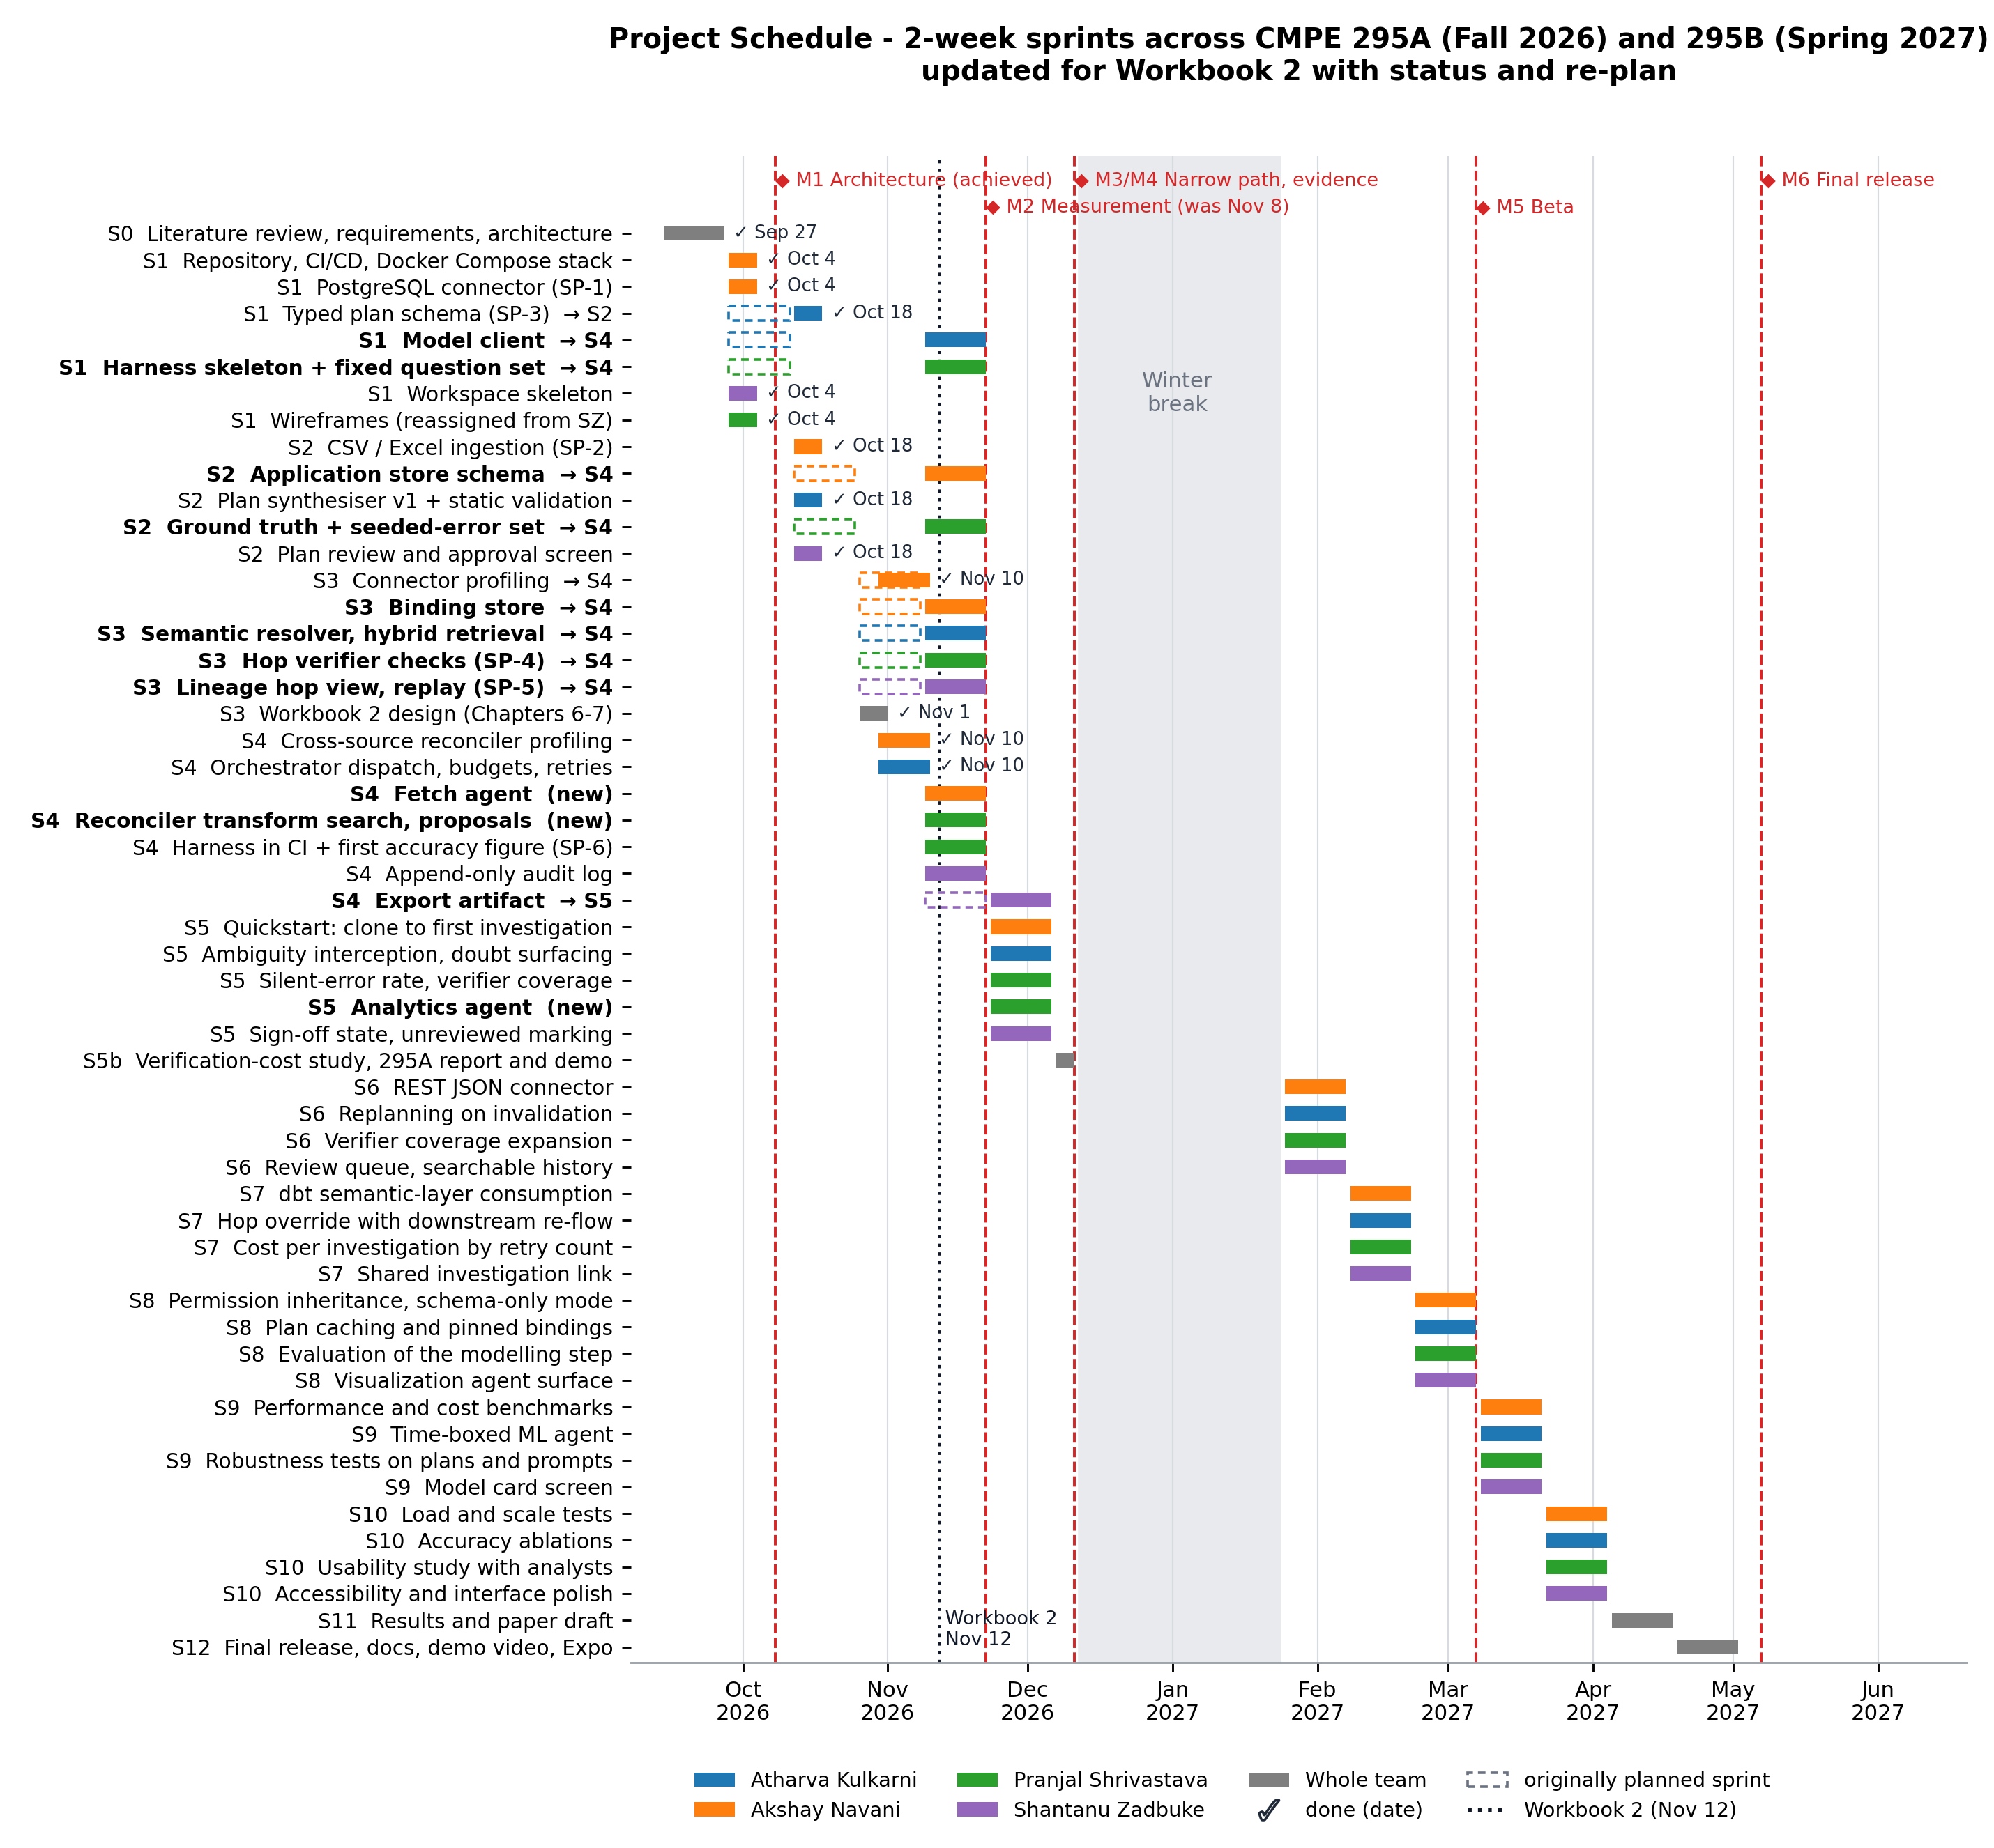

Sprint plan and task assignment
- Task assignment per sprint
Sprint (dates) | Atharva Kulkarni | Akshay Navani | Pranjal Shrivastava | Shantanu Zadbuke
S0 (Sep 14 – Sep 27) | Agent and planning literature; requirements | Text-to-SQL literature; architecture | Reliability and evaluation literature; dependencies | State of the art; justification; screen sketches
S1 (Sep 28 – Oct 11) | Typed plan schema; model client spike (SP-3) (schema done in S2, Oct 18; model client moved to S4) | Repository, CI, Docker Compose; Postgres connector (SP-1); DuckDB path (SP-2) (repository, CI, Docker Compose and SP-1 done Oct 4; DuckDB path done Oct 18) | Harness skeleton; fixed question set drafted (moved to S4); wireframes (reassigned from SZ, done Oct 4) | Investigation workspace skeleton; wireframes (workspace skeleton done Oct 4; wireframes reassigned to PS)
S2 (Oct 12 – Oct 25) | Plan synthesiser v1 with static validation (done Oct 18) | CSV and Excel ingestion; application store schema (CSV and Excel done Oct 18; application store moved to S4) | Ground-truth answers; seeded-error set; hop-check spike (SP-4) (moved to S4) | Plan review and approval screen (done Oct 18)
S3 (Oct 26 – Nov 8) | Semantic resolver: hybrid retrieval and margin threshold (moved to S4) | Connector profiling; binding store persistence (profiling done Nov 10; binding store moved to S4) | Hop verifier checks; first verifier-coverage run (moved to S4) | Lineage inspector hop view; replay spike (SP-5) (moved to S4)
S4 (Nov 9 – Nov 22) | Orchestrator dispatch; budgets and retry caps (done Nov 10); model client and runtime environment; semantic resolver | Cross-source reconciler profiling (done Nov 10); fetch agent; application store and binding store | Harness in CI; first published accuracy figure (SP-6); question set, ground truth and seeded errors; hop verifier (SP-4); reconciler transform search and mapping proposals | Export artifact; append-only audit log; lineage recorder, hop view and replay (SP-5); export moved to S5
S5 (Nov 23 – Dec 6) | Ambiguity interception; doubt surfacing | Quickstart: clone to first investigation under 30 minutes | Silent-error measurement; verifier coverage reported; analytics agent | Sign-off state; unreviewed-answer marking; export artifact
Dec 7 – Dec 11 | Verification-cost study, five analysts (joint) | 295A report and demo (joint) | Results write-up (joint) | Demo preparation (joint)
Winter break (Dec 12 – Jan 24) | Design notes for Workbook 2 (optional) | Deployment notes (optional) | Seeded-error expansion (optional); screen mockups v2 (optional, reassigned from SZ) | Screen mockups v2 (optional) (reassigned to PS)
S6 (Jan 25 – Feb 7, 2027) | Replanning on invalidation | REST JSON connector | Verifier coverage expansion | Review queue; searchable history
S7 (Feb 8 – Feb 21) | Hop override with downstream re-flow | dbt semantic-layer consumption | Cost per investigation by retry count | Shared investigation link
S8 (Feb 22 – Mar 7) | Plan caching and pinned bindings | Permission inheritance; schema-only mode | Evaluation of the modelling step | Visualization agent surface
S9 (Mar 8 – Mar 21) | Time-boxed ML agent | Performance and cost benchmarks | Robustness tests on plans and prompts | Model card screen
S10 (Mar 22 – Apr 4) | Accuracy ablations | Load and scale tests | Usability study with analysts | Accessibility and interface polish
S11 (Apr 5 – Apr 18) | Paper: method and results | Paper: systems and cost | Paper: evaluation and coverage | Paper: figures and user study
S12 (Apr 19 – May 2) | Final hardening | Release packaging and runbooks | Final measurement run | Demo video and Expo booth

Dependencies and Critical Path
Figures 11 and 12 are PERT charts for the two semesters. In CMPE 295A the critical path runs from the PostgreSQL connector through the plan synthesiser, orchestrator dispatch, the fetch agent, the hop verifier, the lineage recorder and export to M3, then through the verification-cost study to M4; the model client must land before the fetch agent. Any slip on that path moves M3, so those tasks are reviewed first at each sprint demo. In CMPE 295B the four member streams run in parallel with equal duration, so a slip in any one of them delays the M5 Beta; after Sprint 10 the critical path is the shared chain through the paper and the release to M6.

- PERT chart for CMPE 295A (Fall 2026) with dependencies and critical path
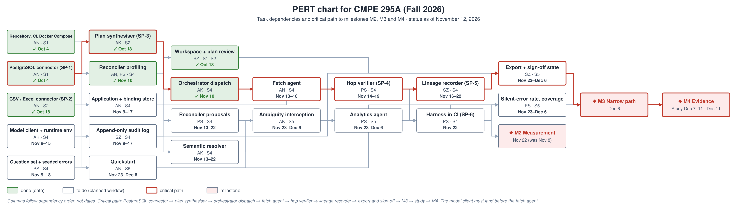
- PERT chart for CMPE 295B (Spring 2027) with dependencies and critical path


